NetSentinel AI Lab
  - Explainable Network Anomaly Detection
and Traffic Simulation
A Project Report
Submitted in partial fulfilment of the requirements
for the degree of
Master of Science in Computer Science
Submitted by
[Student Name]
[Register Number]
Under the guidance of
[Supervisor Name and Designation]
[Department Name]
[College or Institution Name]
[University Name]
Academic Year [Academic Year]
[Place]

Abstract
NetSentinel AI Lab is a local research application for reproducible study of network behaviour, anomaly detection and model explanation. It addresses the difficulty of demonstrating machine learning on private, unpredictable live traffic by generating virtual packet metadata for routine, bulk-transfer, fanout, SYN-burst and UDP-burst scenarios. The simulator emits no generated network traffic. It reuses the original sensor aggregation contract to produce seven features over ten-second windows, while preserving incomplete observations and explicit SIMULATION provenance.
The system combines a Next.js and React workbench, an authenticated Django job API, a separate SQLite demonstration database and an independent Python worker. Complete runs are assigned to training, validation and test partitions. Isolation Forest is trained on benign windows and calibrated on benign validation scores. Random Forest predicts generated behaviour families and is compared with a most-frequent baseline and fixed heuristic rules. Selected classifier predictions are explained using SHAP with an independent numerical additivity check. Cancellation, bounded history, artifact hashes, restart persistence and semantic PDF export support an inspectable experiment lifecycle.
In the retained default seed-42 experiment, 1500 windows and 178812 metadata events produced 293 complete held-out test observations. Random Forest achieved 88.74 percent accuracy and macro F1 of 0.8774, compared with 0.7862 for heuristic rules and 0.1077 for the dummy baseline. The anomaly detector achieved 87.50 percent precision but only 5.51 percent challenge recall at its conservative threshold. A three-seed study produced mean Random Forest macro F1 of 0.8806. These results demonstrate performance within the generator and do not establish real-world intrusion detection accuracy.
The project delivers a usable and tested academic prototype with transparent limitations. Its contribution is the integrated reproducible workflow, scientific separation and explanation validation rather than a new learning algorithm. The existing public connection helper, Windows companion preview and research monitor are retained with separate security boundaries. External dataset validation, current PostgreSQL acceptance and production Windows release remain distinct future gates.
Keywords: network anomaly detection; reproducible simulation; Isolation Forest; Random Forest; SHAP; explainable machine learning; provenance.
Table of Contents
Abstract 2
Chapter 1 Introduction 9
1 1 Background 9
1 2 Problem statement 9
1 3 Aim and objectives 9
1 4 Research questions 10
1 5 Scope and contribution 10
1 6 Report organization 10
Chapter 2 System Specification 11
2 1 Operating environment 11
2 2 Software components 11
2 3 Functional requirements 12
2 4 Quality and security requirements 13
2 5 Data requirements and retention 13
Chapter 3 System Analysis 15
3 1 Analysis of the earlier system 15
3 2 Proposed system 15
3 3 Literature and component review 16
3 4 Feasibility analysis 17
3 5 Threat and failure analysis 17
3 6 Use cases and actors 18
Chapter 4 System Architecture and Module Description 19
4 1 Architectural overview 19
4 2 Scenario generation module 20
4 3 Training and evaluation module 20
4 4 Explanation module 20
4 5 Experiment service and worker 20
4 6 Browser workbench and reports 21
4 7 Supporting public utility 22
4 8 Supporting Windows companion and research sensor 22
Chapter 5 System Design 23
5 1 Design principles and notation 23
5 2 Level 1 data flow 23
5 3 Level 2 analysis flow 24
5 4 Dataset and feature design 26
5 5 Partition and evaluation design 27
5 6 Database architecture 28
5 7 Laboratory table design 30
5 8 Companion table design 31
5 9 Interface and API design 32
5 10 User interface and report design 33
Chapter 6 System Implementation 34
6 1 Source organization 34
6 2 Metadata generation 35
6 3 Model training 35
6 4 Evaluation calculations 36
6 5 SHAP implementation and compatibility handling 37
6 6 Durable jobs and process control 37
6 7 Authentication and validation 37
6 8 Supporting measurement and security implementation 38
6 9 Packaging and release state 38
Chapter 7 System Testing 39
7 1 Testing approach 39
7 2 Scientific correctness tests 40
7 3 Security and reliability tests 40
7 4 Frontend and report tests 41
7 5 Significant failures and resolutions 42
7 6 Remaining verification 42
Chapter 8 Results and Discussion 43
8 1 Experiment configuration and evidence 43
8 2 Classification results 43
8 3 Confusion and family level behaviour 44
8 4 Anomaly detection results 46
8 5 Repeated seeds and uncertainty 46
8 6 Explanation and performance results 47
8 7 Application results 48
8 8 Threats to validity and discussion 48
Chapter 9 Scope for Future Enhancement 50
9 1 External validation and measurement compatibility 50
9 2 Scientific extensions 50
9 3 Usability and assistant features 50
9 4 Windows and release engineering 50
Chapter 10 Conclusion 52
10 1 Project outcome 52
10 2 Achievement of objectives 52
10 3 Concluding remarks 52
Bibliography 53
Appendix A Installation and User Manual 55
A 1 Laboratory installation 55
A 2 Running an experiment 55
A 3 Shutdown and recovery 55
A 4 Independent command line use 56
A 5 Supporting applications 56
Appendix B API and Data Contracts 57
B 1 Configuration contract 57
B 2 Job requests and responses 57
B 3 Result schema 58
B 4 Boundary failures 58
Appendix C Database Data Dictionary 59
C 1 Dictionary conventions 59
C MonitoringSession fields 59
C CaptureStatus fields 60
C TelemetrySample fields 60
C TrafficWindow fields 62
C ModelVersion fields 63
C AnomalyResult fields 64
C QueueGuard fields 64
C Companion apps fields 65
C Companion usage fields 65
C Companion policies fields 66
C Companion events fields 66
C Companion flows fields 67
C Companion destinations fields 67
C Companion settings fields 67
C 2 Integrity and normalization 68
C 3 Migration and storage procedures 68
Appendix D Test Execution and Acceptance Procedures 69
D 1 Repeatable commands 69
D 2 Manual academic demonstration 69
D 3 Remaining Windows verification 70
Appendix E Evidence Register and Release Handoff 71
E 1 Source and generated evidence 71
E 2 Release classification 71
E 3 License and attribution record 72
Appendix F Glossary and Viva Notes 73
F 1 Glossary 73
F 2 Questions for the project demonstration 73
F 3 Submission completion fields 74

List of Figures
Figure 1 Overall architecture and public local trust boundaries 19
Figure 2 Experiment job states and interruption paths 21
Figure 3 Context DFD for the AI laboratory 23
Figure 4 Level 1 DFD for experiment processing 24
Figure 5 Level 2 DFD decomposition of model analysis 25
Figure 6 Analysis workflow from configuration to report 26
Figure 7 Default run partitions and their permitted uses 28
Figure 8 Research entity relationships and separate laboratory tables 30
Figure 9 Companion entities and enforced versus logical references 32
Figure 10 Measured macro F1 comparison on the seed 42 test set 44
Figure 11 Random Forest confusion matrix with actual families as rows 45
Figure 12 Implemented desktop workbench with actual simulation results 48

List of Tables
Table 1 Environment and operating requirements 11
Table 2 Principal pinned software components 12
Table 3 Requirements and implementation acceptance 13
Table 4 Implemented retention and execution bounds 14
Table 5 Comparison of project approaches 16
Table 6 Principal risks and implemented responses 18
Table 7 Frozen host v1 feature definitions 27
Table 8 Actual application database inventory 29
Table 9 ExperimentJob field design 31
Table 10 Laboratory API summary 33
Table 11 Implementation modules and responsibilities 34
Table 12 Models and fitting protocol 36
Table 13 Recorded application verification ledger 39
Table 14 Scientific test cases and acceptance intent 40
Table 15 Integration and boundary test cases 41
Table 16 Default experiment dataset and split counts 43
Table 17 Default held out classification metrics 44
Table 18 Random Forest per class held out performance 45
Table 19 Default Isolation Forest operating point 46
Table 20 Repeated seed classification and anomaly results 47
Table 21 Measured single experiment performance 47
Table 22 Prioritized remaining work 51
Table 23 Accepted scenario configuration fields 57
Table 24 Principal lab result v1 sections 58
Table 25 monitoring MonitoringSession data dictionary 59
Table 26 monitoring CaptureStatus data dictionary 60
Table 27 telemetry TelemetrySample data dictionary 60
Table 28 telemetry TrafficWindow data dictionary 62
Table 29 detection ModelVersion data dictionary 63
Table 30 detection AnomalyResult data dictionary 64
Table 31 experiments QueueGuard data dictionary 64
Table 32 Companion apps physical schema 65
Table 33 Companion usage physical schema 65
Table 34 Companion policies physical schema 66
Table 35 Companion events physical schema 66
Table 36 Companion flows physical schema 67
Table 37 Companion destinations physical schema 67
Table 38 Companion settings physical schema 67
Table 39 Retained evidence locations relative to the repository 71
Table 40 Project abbreviations and terms 73

Chapter 1 Introduction

1 1 Background
Network analysis must identify the source and completeness of an observation, its calculation and its limitations. A large transfer may be legitimate, and many destinations may reflect ordinary application behaviour. An unusual measurement therefore requires interpretation rather than an automatic declaration of an attack.
Repeatability is another difficulty. A live demonstration may produce few useful examples, expose private information or be difficult to reproduce. Disruptive traffic also creates unnecessary operational risk. NetSentinel addresses these problems with a local laboratory that generates virtual packet metadata, reuses a shared feature extractor, trains real models and evaluates separate generated runs.
The project retains a public connection helper, Windows companion preview and original local research monitor. Their observation and privilege boundaries differ. The AI laboratory is the central subject of this report, with supporting modules documented for maintenance of the complete repository [20].

1 2 Problem statement
Students and junior analysts need a controlled environment in which they can compare ordinary and challenging network patterns, observe statistical errors and explain model decisions. A conventional dashboard alone cannot demonstrate training methodology, data separation or model limitations. Conversely, an isolated notebook often provides weak application integration, incomplete operational controls and no accessible demonstration workflow.
The project problem is to implement a reproducible and explainable network behaviour research prototype that connects scenario design, bounded execution, genuine machine learning, retained evidence and usable reports while preserving privacy and distinguishing simulation from live measurement. The problem includes reliable cancellation, authenticated local access, restart persistence and an honest presentation of missing observations.

1 3 Aim and objectives
The aim is to design and evaluate a local application for explainable network anomaly research using reproducible metadata simulation. The implementation supports the following objectives.
1. Generate seeded routine, bulk transfer, fanout, SYN burst and UDP burst scenarios without transmitting generated packets.
2. Extract a fixed seven-feature representation through the existing sensor aggregation code and preserve incomplete observations explicitly.
3. Train Isolation Forest for deviation detection and Random Forest for scenario classification, with simple comparison baselines.
4. Separate whole runs into training, validation and test sets, and calculate metrics from held-out observations.
5. Explain selected classifier outputs through checked SHAP contributions and training-derived reference values.
6. Provide an authenticated local workbench with actual progress, cancellation, playback, experiment history and semantic reports.
7. Preserve the separate public utility and optional Windows components without exposing local privileged controls to the internet.

1 4 Research questions
RQ1 asks whether a learned classifier distinguishes the generated scenario families more effectively than fixed rules and a most-frequent baseline on unseen runs from the same generator. RQ2 asks how a benign-trained anomaly detector behaves when its threshold is calibrated using a conservative benign validation percentile. RQ3 asks whether the explanation implementation reproduces the classifier output within a stated tolerance. RQ4 asks whether the complete local workflow remains usable and bounded when a job is cancelled, interrupted or reopened after restart.
These questions deliberately avoid a claim that synthetic performance establishes real intrusion detection accuracy. The experiment can test reproducibility, arithmetic, separation and behaviour within its generator. It cannot determine the prevalence of attacks on a real network or prove that a computer is safe.

1 5 Scope and contribution
The principal contribution is the integration of a reproducible experiment protocol with a functioning application: shared feature semantics, controlled jobs, provenance-aware outputs, checked explanations and downloadable evidence. Isolation Forest, Random Forest and SHAP are established open-source methods credited to their authors [1–5]. NetSentinel does not claim to invent those algorithms.
The implemented scope includes the independent command-line laboratory, the local browser workbench and a bounded repeated-seed study. The public website remains a connection utility. A public AI demonstration, a local language-model assistant, external dataset evaluation, production signing and renewed live hardware acceptance are future work. No synthetic model is automatically promoted to LIVE, and no anomaly score triggers a firewall block.

1 6 Report organization
The report proceeds through specification, analysis, architecture, design, implementation, testing and measured results before discussing future work and conclusions. Appendices provide setup, API contracts, database fields, evidence and demonstration procedures.

Chapter 2 System Specification

2 1 Operating environment
The reference environment is a Windows x64 student laptop. The completed AI demonstration uses Python 3.11, separate laboratory and backend environments, and a Node.js frontend. A GPU, capture driver, administrator account and external paid API are not needed for the simulation workflow. Model fitting runs in a local worker process rather than in a browser or Django request.
The values in Table 1 distinguish software requirements from planning recommendations. An 8 GB RAM machine and several gigabytes of free storage are reasonable setup recommendations for development, but they are not experimentally established minimum specifications. The observed process memory in Chapter 8 concerns one bounded run and does not include every process or the operating system.
Table 1 Environment and operating requirements
Area | Specification | Scope
Operating system | Windows x64 | Reference platform for the local demonstration
Python | 3.11 with separate environments | Laboratory and backend dependencies
Node.js | 22 or later | Frontend build and local server
Memory | 8 GB recommended for development | Planning guidance, not a measured minimum
Storage | Several GB of free space recommended | Source, environments, builds and bounded artifacts
Browser | Modern JavaScript browser | Desktop and 360 px layout verification recorded
Network | Not required by core lab CLI | Initial downloads and public external tests require access
Privileges | Standard user for AI Lab | Native capture and optional broker have separate prerequisites

2 2 Software components
The project preserves its existing frontend lockfile and backend requirements and uses a separate hash-pinned laboratory lock. This separation avoids changing the original live model environment solely to support simulation explanations. The standalone demonstration selects an explicit SQLite configuration. The original research configuration continues to require PostgreSQL; it does not silently fall back to SQLite.
Table 2 Principal pinned software components
Component | Version | Role
Python | 3.11 | Laboratory and native package runtime
Django | 5.2.17 | Backend and job persistence
Django REST Framework | 3.17.2 | REST interface
Next.js | 16.3.8 | Frontend and local gateway
React | 19.3.0 | User interface
TypeScript | 5.9.3 | Frontend type checking
scikit-learn | 1.9.0 | Estimators and scientific utilities
SHAP | 0.51.0 | Checked feature contributions
jsPDF | 4.2.1 | Browser PDF creation
AutoTable | 5.0.8 | Semantic PDF tables
Cloudflare speedtest | 1.14.1 | Optional public throughput measurement

2 3 Functional requirements
The scenario form accepts a seed, runs per family, windows per run, intensity, noise and missing-observation probability. The server validates the complete configuration and rejects unknown fields and invalid numeric values. A user can start a job, observe its actual stage, request cancellation, reopen retained results, play through computed test windows and export a report. Empty and unavailable states must remain visible rather than being filled with demonstration values.
The scientific functions include dataset hashing, complete-run partitioning, train-only reference statistics, classifier and anomaly metrics, a confusion matrix, explanation additivity checks and a reproducible saved model bundle. The comparison study adds repeated seeds, whole-run bootstrap intervals and an excluded-family experiment. The supporting Windows companion discovers observed executables, estimates attributed usage, manages quota intent and presents available Defender and firewall information.
Table 3 Requirements and implementation acceptance
ID | Requirement | Evidence or boundary
FR01 | Repeatable scenario generation | Same configuration reproduces dataset content
FR02 | Real fitting and held-out evaluation | IF, RF, rules and dummy results calculated
FR03 | Explain selected outputs | Independent 0.00001 additivity check
FR04 | Start and cancel bounded jobs | Authenticated queue and worker lifecycle
FR05 | Retain and reopen results | SQLite restart persistence demonstrated
FR06 | Export useful evidence | Semantic PDF and JSON from completed results
FR07 | Preserve provenance | SIMULATION fixed in lab contracts
FR08 | Maintain supporting applications | Public, research and companion boundaries retained
NFR01 | Protect local actions | Session, origin, CSRF and scoped API checks
NFR02 | Remain usable on a laptop | Bounded pipeline and measured process resources

2 4 Quality and security requirements
Correctness requires preserving feature units, numerical bounds and mode labels from generation through reporting. Reliability requires bounded jobs, explicit failures, retained terminal state and cleanup of owned worker processes. Reproducibility requires the configuration, random seed, dataset digest, split manifest, model parameters and environment evidence. Usability requires understandable labels, visible limitations, keyboard access and responsive layouts.
Sensitive operations require authorization at the server boundary. The browser never receives a worker lease or backend credential. The job API accepts a fixed configuration schema rather than uploaded scripts, commands, model files or target URLs. The standalone servers bind to loopback and run without elevation. Only the separately launched optional native broker may perform its narrow Windows operations.

2 5 Data requirements and retention
Laboratory records contain generated metadata and calculated results. The simulation uses documentation address ranges and does not collect payloads, cookies, passwords, browsing URLs or personal messages [16]. Job rows and owned artifact directories are bounded. The model bundle is a private local artifact; a digest supports integrity checking but does not make an unknown serialized model trustworthy.
Table 4 Implemented retention and execution bounds
Area | Limit | Qualification
Experiment execution | 20000 windows; 2000000 events | Over-budget work fails explicitly
Job scheduling | 4 queued and 1 running | Active work is not evicted
Job history | 20 retained jobs | Old terminal rows pruned during operations
Worker lease and timeout | 30 s lease; 600 s job timeout | Expiry processed on next queue access
HTTP check history | 10 checks for 7 days | Optional browser storage
Speed history | 30 completed tests for 30 days | Separate optional store; no provider inventory
Companion discovery | 512 executable identities | Observed paths only
Companion usage | 90 days | UTC daily buckets, separated by mode
Companion flows | 10000 rows and 7 days | Metadata observations, not full connections
Companion events | 2000 rows and 90 days | Bounded control and alert history
Destinations | 5000 records and 30 days | Local observation history

The public HTTP history and speed history are distinct stores with different limits. Provider lookup data is not automatically included in either. A companion usage total is approximate observed IP traffic; it must not be described as an internet provider billing record. A gap in sensor observation must not be converted into zero bytes or a normal model result.

Chapter 3 System Analysis

3 1 Analysis of the earlier system
The earlier research system had an independent Windows sensor, Django persistence, an Isolation Forest workflow and a local dashboard. These are valuable foundations because capture does not depend on the web server, and the host-v1 feature representation already defines consistent aggregation semantics. The public helper subsequently added connection checks, guided troubleshooting, throughput measurement and reports. A native companion added application accounting and Windows security integration.
However, these features did not by themselves form a coherent AI research demonstration. Live traffic could be quiet or private; the application had no integrated scenario-to-training workflow; comparison baselines and explanation compatibility needed explicit evidence. Historical documentation also referred to several different project stages. The current implementation therefore adds a separate simulation laboratory while retaining existing modules and dated evidence.

3 2 Proposed system
The proposed and implemented system allows the user to design an experiment, generate metadata, train models, inspect results and save evidence in one local workflow. The generated dataset is deterministic for a fixed configuration and implementation version. Whole runs are assigned to partitions before windows are generated. Predictor input consists of numeric features; truth labels and identifiers remain separate.
The workbench is backed by a durable job API and one independent worker. This permits cancellation and explicit failure handling without holding an HTTP request open for model fitting. A local SQLite mode makes the AI demonstration usable when the original PostgreSQL service is unavailable. This is a deliberate second runtime, not evidence that the PostgreSQL deployment has passed its current acceptance gate.
Table 5 Comparison of project approaches
Criterion | Earlier workflow | Implemented AI Lab
Input availability | Depends on observed host activity | Seeded metadata scenarios
Scientific repeatability | Requires retained suitable captures | Configuration, hashes and split manifest
Model comparison | Original anomaly workflow | Classifier, anomaly model and two baselines
Explanation | Deterministic reference deviations | Checked SHAP plus training references
Demonstration | Local monitoring views | Scenario, execution, playback and report
Operational control | Independent capture and publication | Durable bounded jobs and cancellation
Interpretation | Host observation limits | Explicit synthetic scope and held-out results

3 3 Literature and component review
Isolation Forest isolates observations through random partitions, using the tendency of unusual observations to require shorter isolation paths [1]. It provides a useful unsupervised comparator when benign training data is available. The project uses the scikit-learn implementation and explicitly defines the sign and threshold of the reported deviation score [4]. It does not interpret that score as the probability of an attack.
Random Forest combines decision trees trained with randomization [2]. In this project it is used for a different question: prediction of an injected scenario family from aggregate features. The reported class probability belongs to that fitted classifier and its generated class definition. It is not a calibrated estimate of malicious intent.
SHAP associates a model output with additive feature contributions relative to a background [3]. The library offers an exact explainer suitable for the small feature space used here [5]. NetSentinel independently checks the sum against the actual classifier output. This check revealed an explanation compatibility problem and justified a disclosed fallback rather than a fabricated explanation.
CICIDS2017 is an established external intrusion-detection dataset documented by the Canadian Institute for Cybersecurity [17]. Only its official description and access information were acquired for this project. Its flow CSV data was not used for training or testing. A future adapter must establish measurement compatibility; matching column names alone is insufficient.

3 4 Feasibility analysis
Technical feasibility is supported by a completed local workflow, independently runnable pipeline, genuine model execution and automated integration evidence. The seven-feature representation permits bounded model fitting and exact explanation fallback on a laptop. A single local queue and worker are sufficient for the current use case; Redis, Celery and a distributed training platform would add complexity without addressing a measured requirement.
Operational feasibility depends on clear local startup, a password-based operator session and an accessible demonstration sequence. The source launcher creates ephemeral service credentials, starts only owned processes and preserves saved results on shutdown. The public helper remains usable without installation. Native firewall or malware scan functions remain separate explicit Windows actions.
Economic feasibility comes from reusing existing hardware and focused open-source components. The core laboratory needs no recurring cloud training or inference service. This does not imply that public bandwidth, code signing, domain registration or future deployment support are free. Those costs require a separate release decision.

3 5 Threat and failure analysis
The primary local threats are unauthorized browser requests, guessed credentials, malformed configurations, oversized results, arbitrary model deserialization and resource exhaustion. Defensive controls include exact origin validation, CSRF checks, scoped bearer credentials, bounded request bodies, generated job identifiers, independent result validation and a single running job. Forwarded headers are not treated as proof that a request originated locally.
Scientific failures are equally important. Label leakage can inflate accuracy, random window splitting can transfer near-duplicate temporal context into the test set, and presentation can hide unavailable measurements. The implemented split protocol, separate truth sidecar, train-only references and explicit unscored counts address these concerns within the generator. They do not eliminate the larger limitation that all primary experimental data comes from one simulator.
Table 6 Principal risks and implemented responses
Risk | Response | Residual limitation
Label leakage | Separate truth and numeric inputs | Shared generator assumptions remain
Temporal dependence | Partition whole runs | Few independent runs per seed
Untrusted local request | Authentication, origin and CSRF checks | Local machine compromise is outside protection
Resource exhaustion | Budgets, queue cap and timeout | Operating system load affects latency
Misleading explanation | Actual-output additivity guard | No causal guarantee
Lost observation | Null features and explicit counts | Unobserved behaviour cannot be reconstructed
Privileged misuse | Separate broker and fixed operations | Production native release gates remain
Public exposure | Static source allowlist | New publication requires artifact review

3 6 Use cases and actors
The student operator configures and runs experiments. The examiner reviews the methodology, playback, metrics and reports. A public visitor uses connection assistance in an independent browser experience. A Windows operator may explicitly use the companion and launch its broker when privileged actions are intended. These actors describe interaction responsibilities; the project does not implement a cloud organization or enterprise role hierarchy.
The principal use case begins with local sign-in, continues through scenario submission and worker completion, and ends with examination or export of a result. Alternate paths include an invalid form, a full queue, a cancelled job, an expired worker lease and a temporarily unavailable backend. Each alternate path has an explicit state; none is relabelled as a successful experiment.

Chapter 4 System Architecture and Module Description

4 1 Architectural overview
The architecture separates public browsing, local application access, independent computation and optional native privilege. The static public website cannot call a local training worker or firewall broker. The local Next.js application authenticates its operator and relays only fixed API actions to Django. Django validates and persists jobs, while a worker process generates data and fits models. The companion is a distinct local service with its own private state.
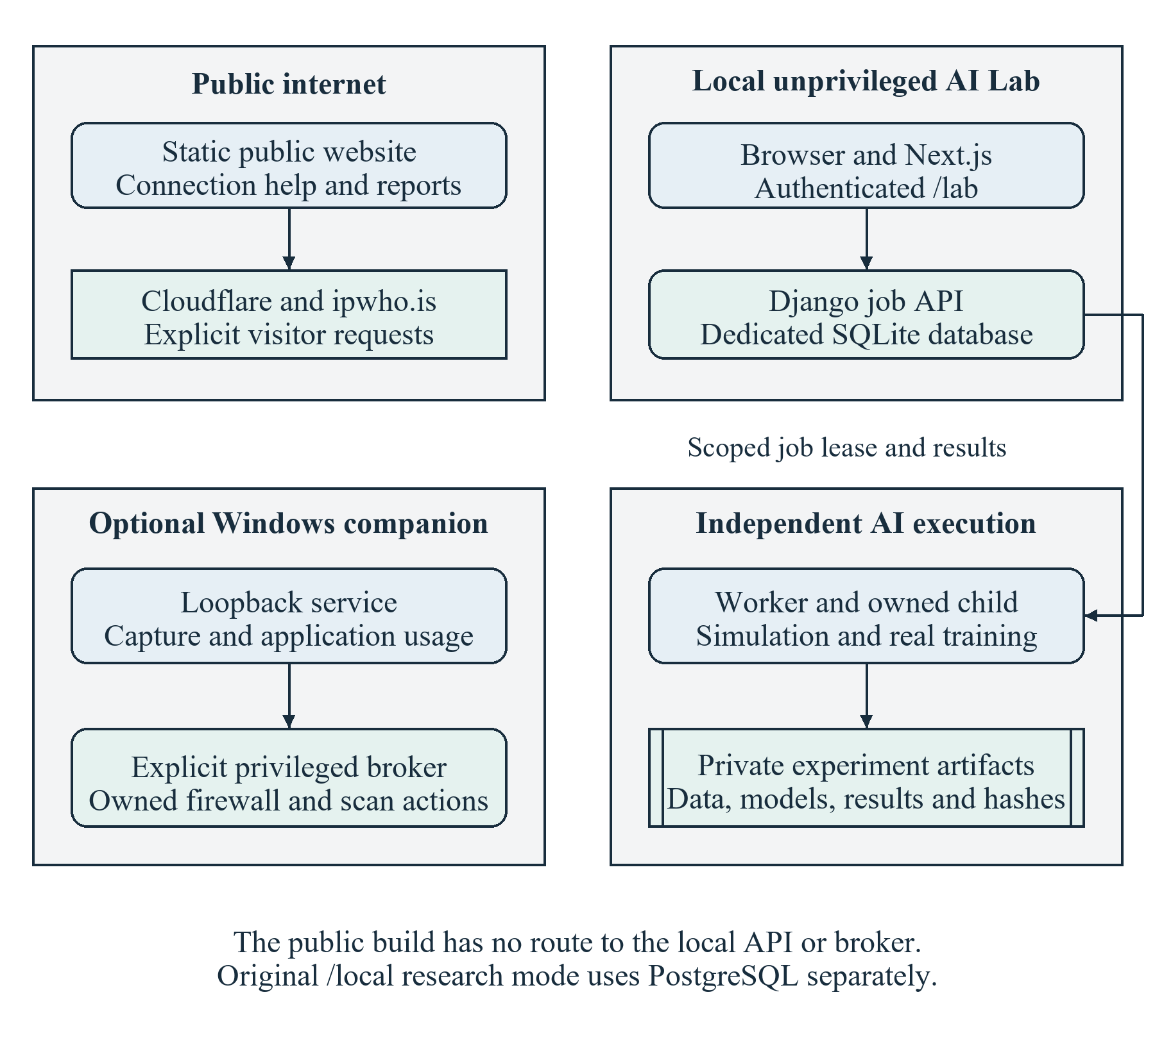
Figure 1 Overall architecture and public local trust boundaries
The original research monitor is a supporting runtime using PostgreSQL, telemetry ingestion and its own model metadata. The standalone lab configuration installs only the experiment application and its routes. Therefore a successful standalone demonstration does not establish that research database migration, current live capture or privileged Windows enforcement has been verified.

4 2 Scenario generation module
The lab.simulation module constructs packet metadata for five families with deterministic per-run seeds. Routine and bulk-transfer roles represent benign workloads; fanout, SYN burst and UDP burst are challenge patterns. Noise introduces overlapping distributions, and challenge runs contain routine windows. An injected family is an experimental label, not evidence that an equivalent real pattern is malicious.
Metadata is passed through the existing sensor aggregation implementation. This avoids creating a separate feature definition solely for the classifier. The generator enforces window and event budgets and checks cancellation during work. No socket transmission, target scanning or packet payload generation is required.

4 3 Training and evaluation module
The lab.models, lab.metrics and lab.pipeline modules fit the estimators, calculate predictions and assemble the result contract. Isolation Forest uses benign training observations. Random Forest uses the complete set of valid training families. A most-frequent classifier and ordered heuristic rules provide comparison points. Calibration uses benign validation scores; the held-out test set does not determine the threshold.
The pipeline records model parameters, feature order, training window counts, reference quantiles, evaluation metrics and measured timing. lab.artifacts writes dataset, truth, split, model and environment evidence with hashes. A model can be reloaded only through the trusted local workflow and compatibility checks. Django stores a bounded result summary rather than executing serialized model files.

4 4 Explanation module
lab.explanations selects at most eight cases and uses at most 64 training rows as the SHAP background. It attempts the supported tree explanation path and independently checks all class outputs. When the contributions fail the numerical guard, a bounded ExactExplainer path evaluates the actual Random Forest prediction function with the same background. The method and reason for fallback are retained in the result.
The interface shows each feature value, a training-derived reference and its contribution for the predicted class. A positive contribution moves the output above the background expectation; a negative contribution moves it below. Contributions describe the model under its masking assumptions. They do not prove causal effects, validate the scenario label or identify an attacker.

4 5 Experiment service and worker
The experiments Django application owns admission, job transitions, leases, cancellation and retained results. Queue operations serialize access using a database-appropriate lock and an additional unique constraint for the running state. Browser read and mutation credentials are separate from the worker credential. Only the worker can claim or finish a job using an active lease.
The worker spawns an owned child for computation so that fitting can be terminated when required. It maintains a heartbeat, checks cancellation and applies a 600-second job timeout. Expired running jobs become explicit failures when the queue is next accessed. Parent-death handling and owned-process cleanup prevent an interrupted launcher from leaving an unbounded training process behind.
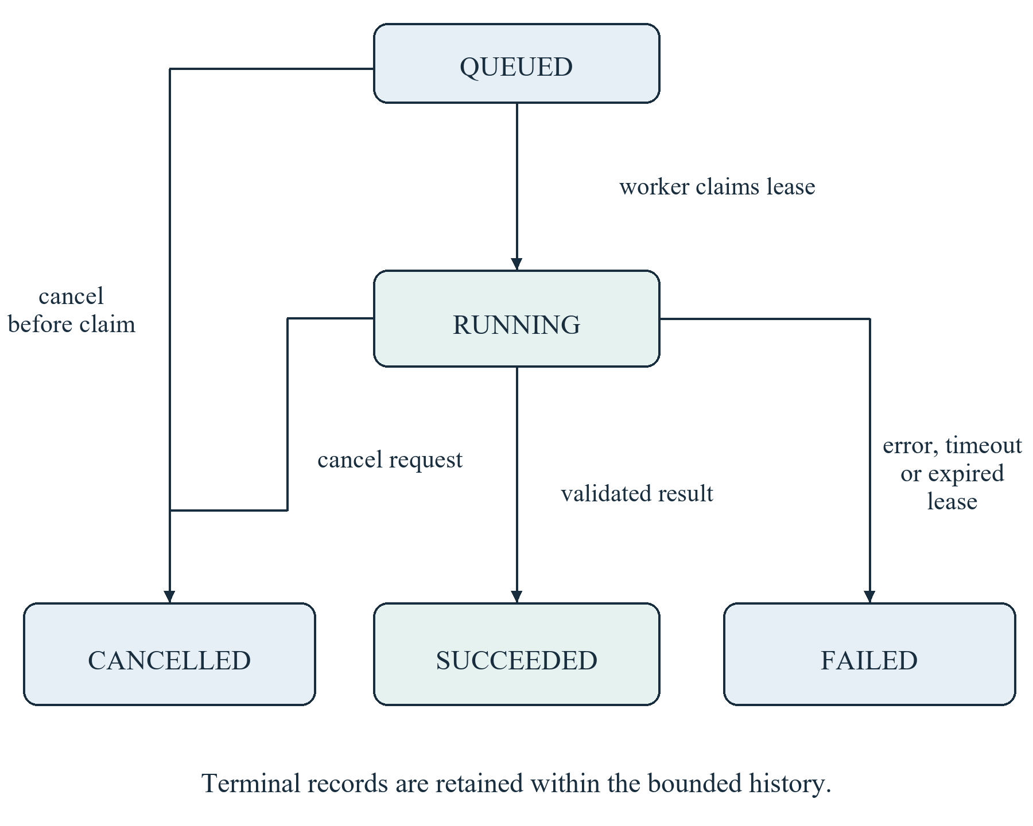
Figure 2 Experiment job states and interruption paths

4 6 Browser workbench and reports
The /lab interface comprises scenario controls, retained experiments, current job state, result summaries, recorded playback, a generated-truth overlay, model comparisons, explanations and usage guidance. Playback advances through already computed test windows. It does not generate live traffic or retrain a model for every displayed frame.
The workbench uses vanilla CSS with translucent panels and a deep teal navigation area. Compact layouts stack controls and evidence panels. Wide tables are contained in labelled scrolling regions. Error, gap, empty and stale states are treated as normal parts of the interface. Semantic PDF export uses text, tables and charts; the report is not a screenshot of the dashboard.

4 7 Supporting public utility
The public utility provides a small same-origin connection check, guided troubleshooting, a transfer-time calculator, optional history and reports. A separate explicit throughput test uses the pinned Cloudflare engine [12]. Provider details are fetched directly from the visitor browser through ipwho.is after consent [13]. This avoids mistaking a cloud server's outbound address for the visitor's public address.
Public measurements describe their actual scope. HTTP timing includes browser and server effects; it is not ICMP ping or packet loss. Speed samples measure application payload throughput over configured requests, not maximum line capacity. A VPN or proxy may change the apparent provider and approximate location. The public export contains no private monitor, experiment API, backend credentials or model artifacts.

4 8 Supporting Windows companion and research sensor
The companion correlates observed packets with process socket snapshots, groups matching executable identities and retains ambiguous traffic as unassigned. This is approximate attribution because sockets can change between observations. Daily and monthly UTC usage buckets support quota warnings, manual intent, optional automatic blocking and an override until reset. An applied firewall rule is distinct from a measured proof that traffic stopped.
Microsoft Defender remains responsible for malware detection and remediation. NetSentinel presents documented status and explicit scan controls [10, 11]. It does not implement antivirus signatures or custom quarantine. The independent original sensor remains useful without Django, PostgreSQL or a model; its local results preserve capture quality and LIVE, SIMULATION or REPLAY provenance.

Chapter 5 System Design

5 1 Design principles and notation
The design preserves the difference between an observation, an inferred class, a statistical deviation and a control action. Each observation retains its measurement source and mode. Missing evidence remains unavailable. Authenticated control paths use fixed schemas and bounded work. Public and local builds are separated by an allowlist of source files rather than merely by hidden navigation links.
The following data flow diagrams use rectangles for external entities, rounded rectangles for processes, double-sided rectangles for data stores and directed arrows for data movement. The context diagram treats local artifact storage as an external filesystem service. Internal job and experiment stores are expanded in the level 1 diagram. A DFD shows data movement, not deployment privileges or exact execution timing.
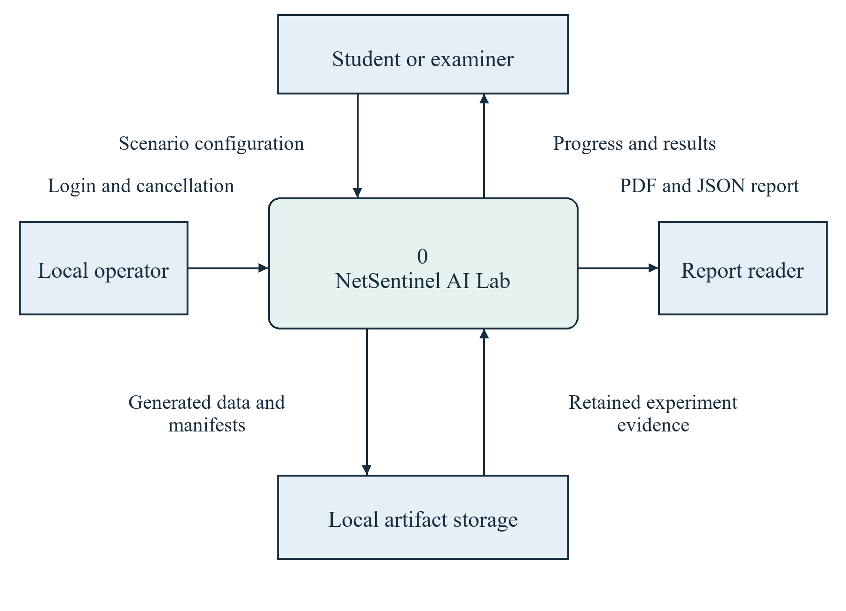
Figure 3 Context DFD for the AI laboratory

5 2 Level 1 data flow
The level 1 DFD decomposes the laboratory into validation and queuing, generation and partitioning, training and evaluation, and presentation and export. Job state belongs to the database. Numeric dataset records, truth sidecars and model files belong to the worker's private artifact area. The frontend consumes a validated result through the API rather than opening model files.
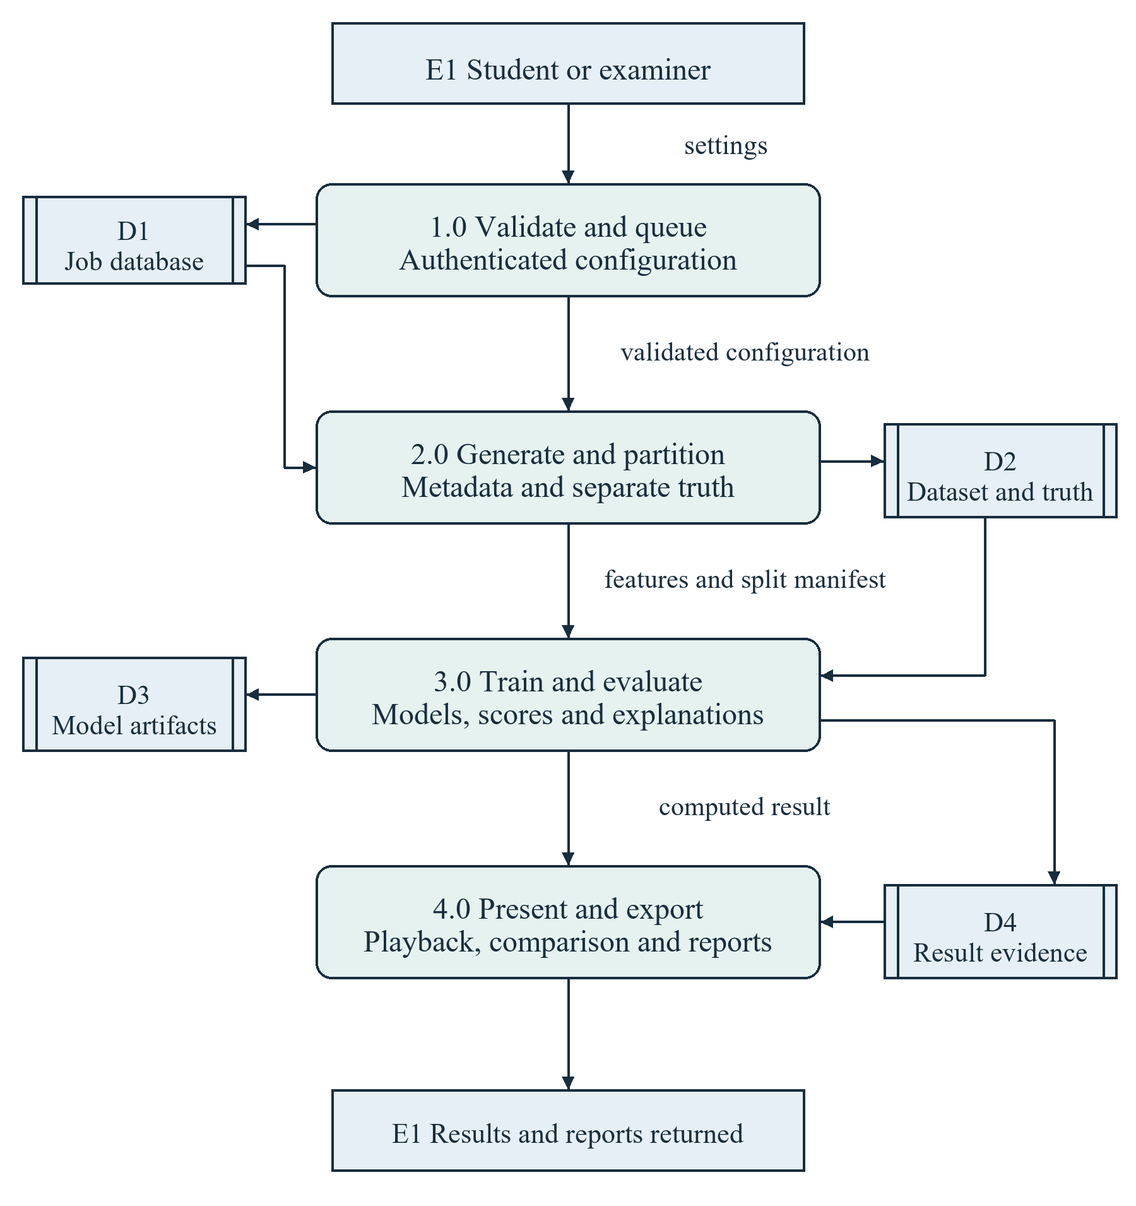
Figure 4 Level 1 DFD for experiment processing
Truth labels flow into evaluation and into the optional presentation overlay. They must not flow into the estimator's numeric input matrix. This boundary is essential because a predictor that receives its label, run identity or generation seed would produce misleading results even if the user interface and metric calculation were otherwise correct.

5 3 Level 2 analysis flow
The level 2 decomposition expands training and evaluation. The workflow first selects complete observations, then fits models, calibrates the anomaly threshold, infers on untouched test runs, compares predictions with truth and validates explanations. Results include unscored counts so that excluding incomplete records remains visible.
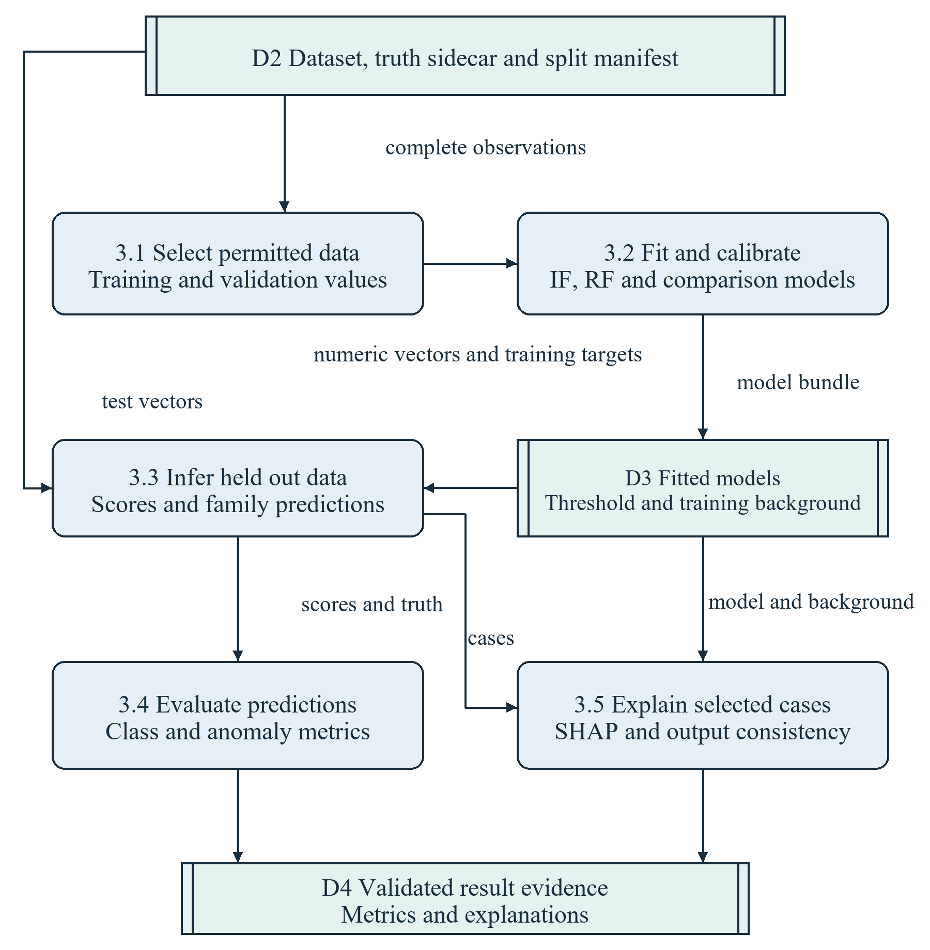
Figure 5 Level 2 DFD decomposition of model analysis
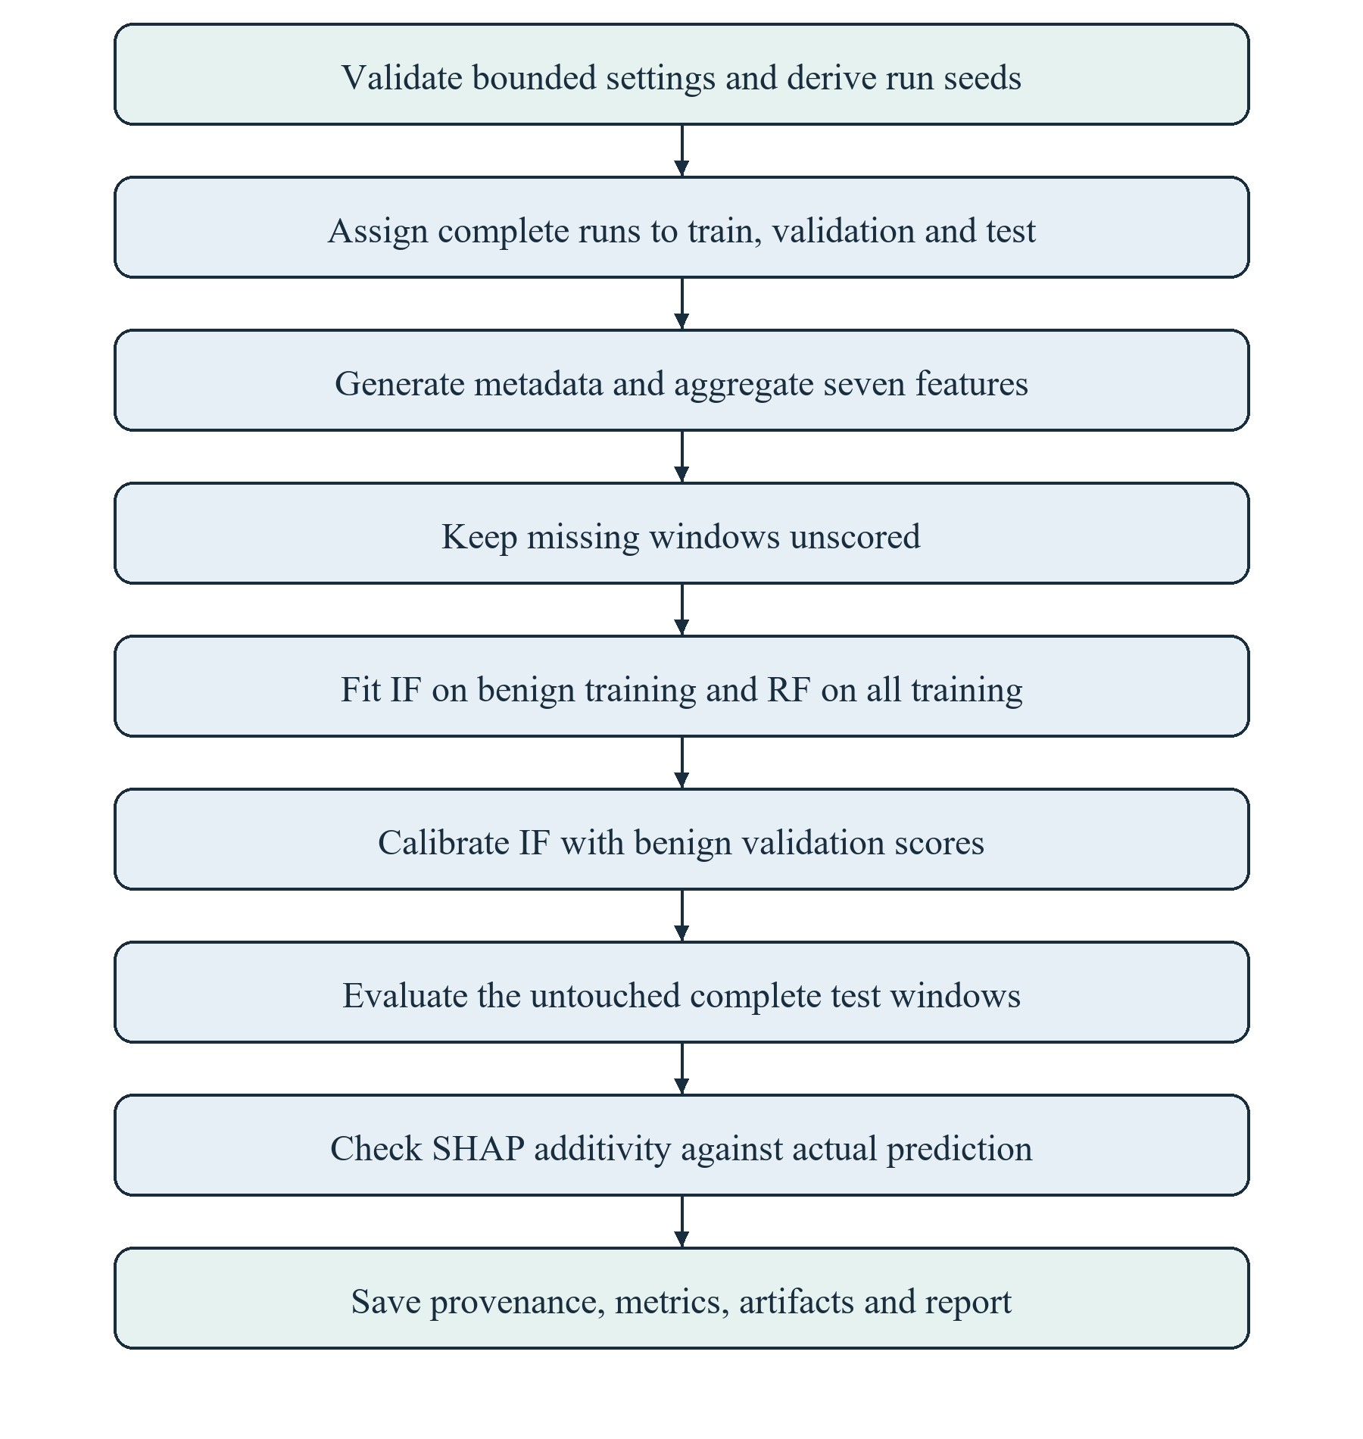
Figure 6 Analysis workflow from configuration to report

5 4 Dataset and feature design
The unit of model input is one complete ten-second window. The seven ordered host-v1 values are calculated from finalized directional and protocol aggregates. Ratios use a stated zero-denominator convention only when the window is otherwise complete. An invalid or partial window produces no feature vector; it is not represented by a vector of zeros.
Table 7 Frozen host v1 feature definitions
Feature | Calculation | Unit
packets_​per_​second | Observed IP packets /​ 10 | packets/​s
ip_​bytes_​per_​second | Observed IP bytes /​ 10 | bytes/​s
outbound_​byte_​fraction | Outbound bytes /​ known directional bytes | 0 to 1
unique_​remote_​peers | Distinct remote IPs in complete window | count
tcp_​syn_​fraction | TCP SYN packets /​ TCP packets | 0 to 1
udp_​fraction | UDP packets /​ all observed IP packets | 0 to 1
mean_​ip_​packet_​bytes | IP bytes /​ observed IP packets | bytes/​packet

The public speed-test units are separate from these feature units. An IP byte count in a sensor window is not a browser response-body count. Neither includes every link-layer overhead, retransmission accounting rule or internet provider charging rule. These distinctions prevent results from different products being combined as though they were the same measurement.

5 5 Partition and evaluation design
Whole runs are assigned independently within each family: floor 60 percent to training, at least one run from floor 20 percent to validation, and the remainder to testing. With the default ten runs per family, each family has six training, two validation and two test runs. There is no random shuffle of windows across these boundaries.
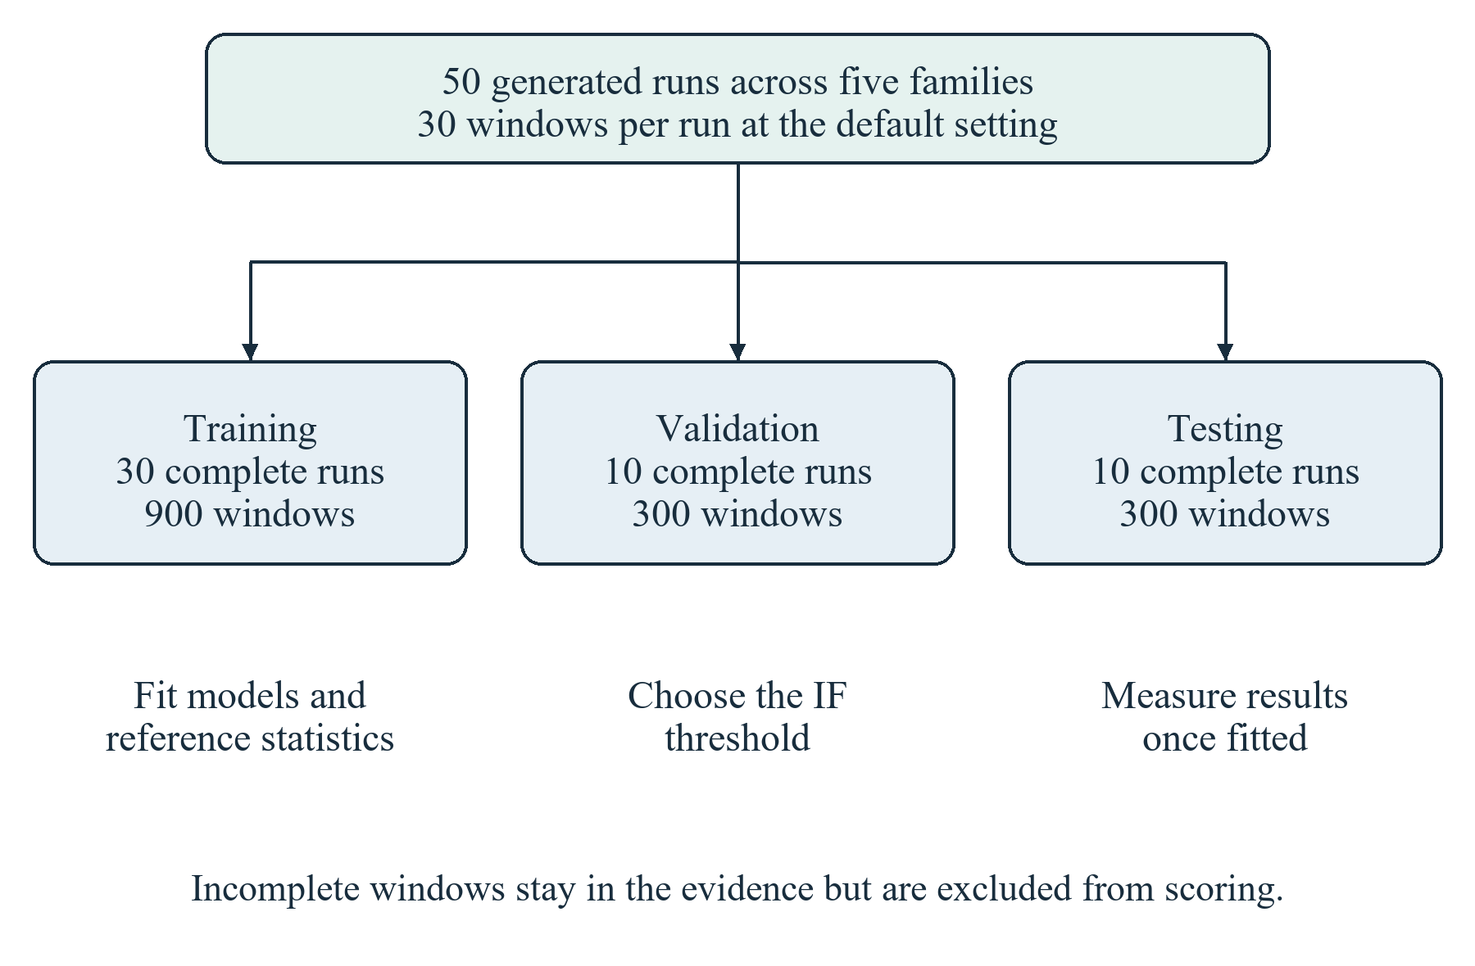
Figure 7 Default run partitions and their permitted uses
Related windows within a generated run are not independent experimental replications. The repeated-seed study therefore resamples complete held-out runs for conditional uncertainty intervals. This preserves within-run structure. It still does not measure uncertainty over all possible training populations or establish transfer to a different traffic generator.

5 6 Database architecture
The repository contains three distinct persistence contexts. The original research backend uses six application models in PostgreSQL. The standalone laboratory uses ExperimentJob and QueueGuard in its own SQLite database. The companion uses seven manually defined SQLite tables. Django migration bookkeeping and framework internals are not counted as application domain tables.
Table 8 Actual application database inventory
Context | Tables | Relationship to release
Standalone lab SQLite | experiments_​experimentjob; experiments_​queueguard | Verified local prototype database
Original research PostgreSQL | monitoring_​monitoringsession; monitoring_​capturestatus; telemetry_​telemetrysample; telemetry_​trafficwindow; detection_​modelversion; detection_​anomalyresult | Source retained; current PostgreSQL acceptance blocked
Companion SQLite | apps; usage; policies; events; flows; destinations; settings | Separate native preview state

The original session model is the parent of telemetry, traffic windows and capture status. Anomaly results refer to a window, a model version and a session. Service validation verifies cross-record agreement in addition to database constraints. ModelVersion stores metadata rather than an executable model blob. The full field-level dictionary appears in Appendix C.
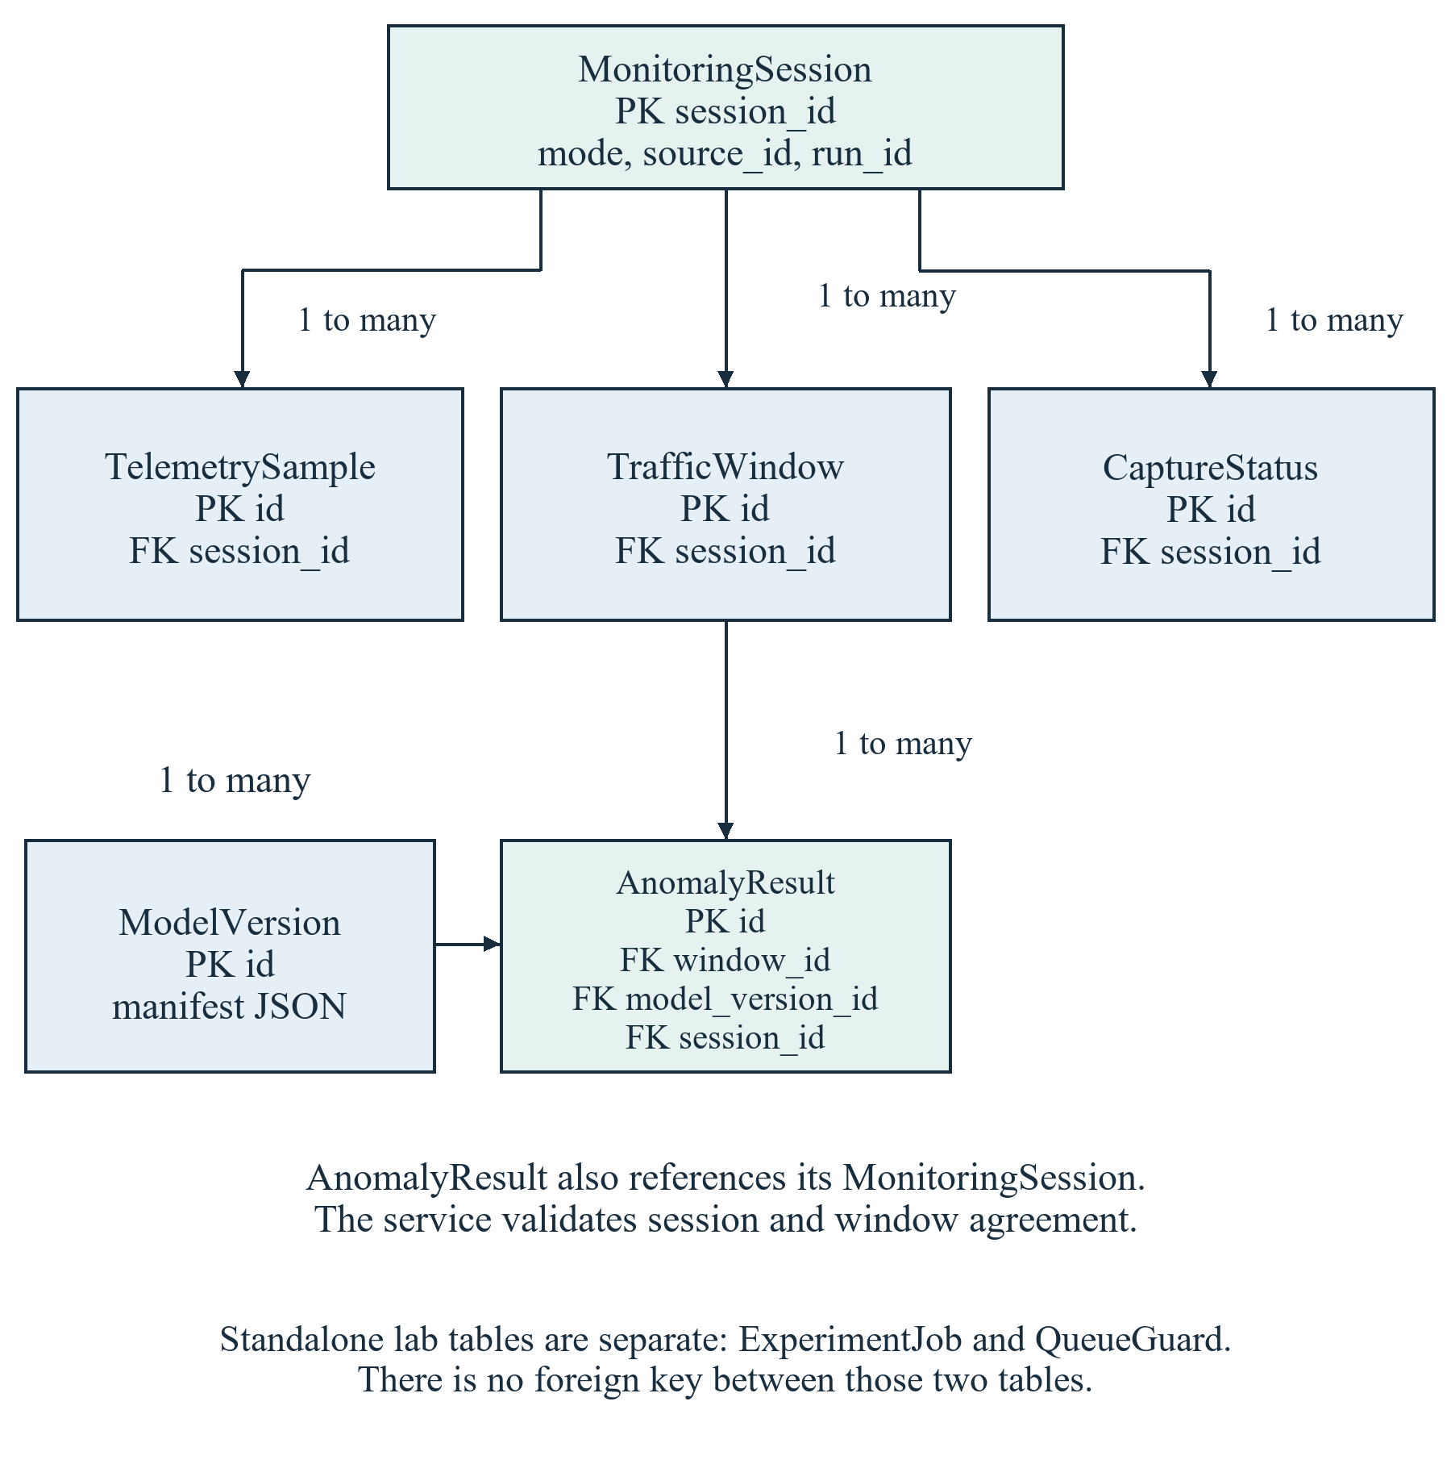
Figure 8 Research entity relationships and separate laboratory tables

5 7 Laboratory table design
ExperimentJob is intentionally cohesive: its bounded configuration and result are JSON fields, while identity, state, lease and progress are typed columns with constraints. This avoids scaffolding separate dataset, model, metric and explanation tables when the application reads a completed experiment as one bounded unit. The trade-off is reduced database-level querying of individual metrics and a greater need for application schema validation.
Table 9 ExperimentJob field design
Field | Type and nullability | Purpose
id | UUID, PK | Generated job identity
status | Text 12, required | QUEUED, RUNNING, SUCCEEDED, FAILED or CANCELLED
stage | Text 48, required | Actual execution phase
created_​at | UTC datetime | Creation time
updated_​at | UTC datetime | Most recent saved update
config | JSON, required | Validated complete settings
cancel_​requested | Boolean, default false | Cancellation intent
completed | Unsigned integer, nullable | Completed progress units
total | Unsigned integer, nullable | Expected progress units
error | Text 200, blank allowed | Fixed redacted error description
result | JSON, nullable | Validated result only on success
lease_​digest | Text 64, blank allowed | Digest of active worker lease
lease_​expires_​at | UTC datetime, nullable | Lease renewal deadline

QueueGuard contains only id and revision. A check constrains id to one, and a seeded row supports the SQLite write lock before queue state is read. It has no foreign key to ExperimentJob. The PostgreSQL runtime uses an advisory transaction lock for the same admission operation. These are implementation-specific concurrency mechanisms, not interchangeable verification results.
The job constraints permit only known states, allow a non-null result only for SUCCEEDED, require completed progress not to exceed total when both are present, and allow a single RUNNING row. An index on status and created_at supports queue queries. Lease digests are never serialized to the browser. A SHA-256 digest stores the worker lease comparison value without retaining the raw lease in the row.

5 8 Companion table design
Executable identity uses a hash of a normalized canonical path so subprocesses using the same executable can be grouped. This identifies an observed executable location; it is not a cryptographic verification of the file's publisher or contents. The schema stores quota intent separately from usage, allowing configuration to survive a restart without implying that a firewall rule is currently effective.
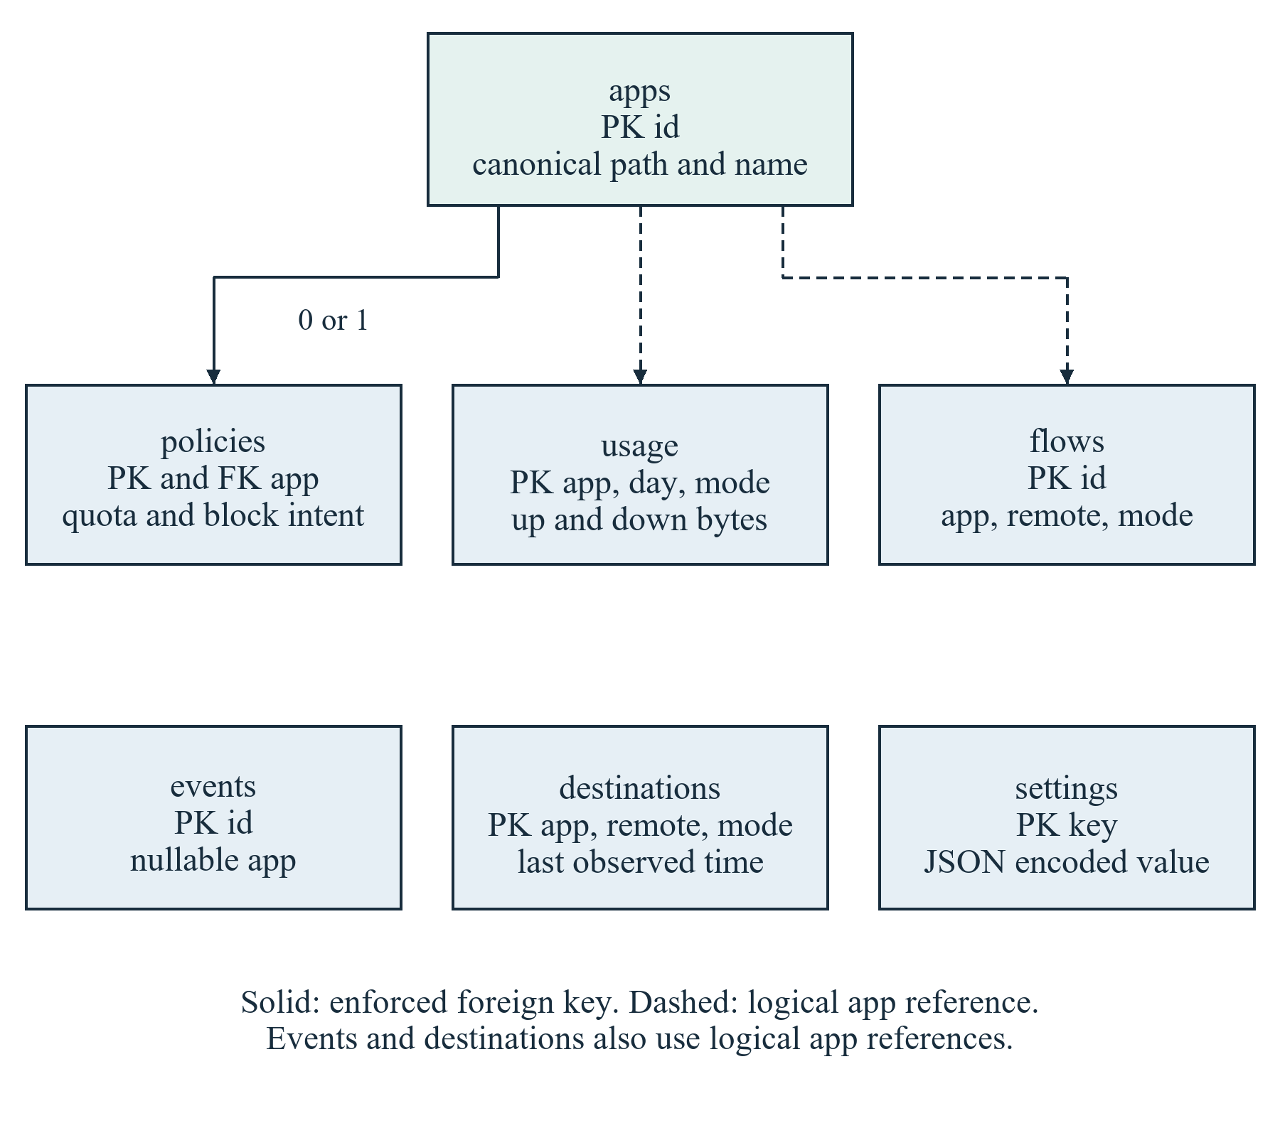
Figure 9 Companion entities and enforced versus logical references
Only policies.app declares a foreign key to apps.id in the current schema. Other app fields are logical references maintained by application logic. usage also needs the special unassigned identity. This design is documented as implemented rather than depicting stronger relational constraints that do not exist. SQLite foreign key enforcement is explicitly enabled for the connection [18].

5 9 Interface and API design
The browser creates and cancels jobs through same-origin Next.js routes. The relay checks the operator session, exact origin, CSRF token and local request marker before mutation. It forwards only fixed paths to a configured loopback backend. The backend independently authorizes the required scope and validates input. A public browser cannot obtain local authority merely by knowing an endpoint path.
Table 10 Laboratory API summary
Method and relative route | Scope | Purpose
GET jobs/​ and jobs/​<uuid>/​ | Read token | Summaries and completed result
POST jobs/​ | Lab token | Create a validated job
POST jobs/​<uuid>/​cancel/​ | Lab token | Request or complete cancellation
POST worker/​claim/​ | Worker token | Claim one job with a lease
POST worker/​<uuid>/​heartbeat/​ | Worker token and lease | Renew lease and report progress
POST worker/​<uuid>/​finish/​ | Worker token and lease | Submit terminal outcome

The server returns structured availability rather than forcing every state into a percentage. Progress contains a stage and optional completed and total counts. A cancelled or failed experiment has no successful result. The worker finish endpoint receives a larger result body only after worker authentication. Appendix B defines request examples and failure handling without embedding any credentials.

5 10 User interface and report design
The navigation emphasizes tasks: configure an experiment, inspect retained work, understand results and learn how to use the application. Controls expose bounded inputs with defaults. Results distinguish classification, anomaly detection and unscored observations. The truth overlay is explicitly generated truth, and class confidence is accompanied by its model-output meaning.
The PDF design includes a report title, SIMULATION scope, generation time, configuration, model comparisons, anomaly metrics, explanation evidence and limitations. The public and companion report paths use only data available in their own environments and redact sensitive fields by default. The academic report presented here adds the source architecture, implementation detail and research analysis that are outside the shorter application-generated PDF.

Chapter 6 System Implementation

6 1 Source organization
Implementation extends the existing modular repository. The lab package contains the independent scientific workflow. The experiments Django application implements job persistence and API behaviour. The frontend lab components implement local interaction, and the launcher coordinates the processes. The existing sensor, ml and companion packages retain their distinct responsibilities.
Table 11 Implementation modules and responsibilities
Source area | Responsibility
lab/​contracts.py | Configuration and result validation without ML imports
lab/​simulation.py | Deterministic metadata and truth generation
lab/​models.py and metrics.py | Fitting, prediction and evaluation arithmetic
lab/​explanations.py | Checked SHAP and bounded exact fallback
lab/​pipeline.py and artifacts.py | Experiment orchestration and reproducible evidence
lab/​benchmark.py | Repeated seeds, group bootstrap and family exclusion
lab/​worker.py | Claim, lease, owned child, cancellation and cleanup
backend/​experiments/​ | Job model, migrations, service, validation and API
backend/​config/​lab_​settings.py | Explicit standalone experiment-only SQLite runtime
frontend/​src/​components/​lab/​ | Scenario and results workbench
frontend/​src/​lib/​lab-*.ts | Contracts, gateway and PDF report
scripts/​run_​ai_​lab.py | Local startup, credentials and owned-process shutdown
scripts/​verify_​ai_​lab.py | Actual HTTP integration verification
sensor/​, ml/​, companion/​ | Preserved capture, original research ML and native preview

The separation allows the command-line experiment to run without a database or web server. Django imports lightweight validation contracts but does not import the scientific runtime or load models. The worker owns computation and its artifact directory. This boundary reduces request latency, isolates cancellation and makes the pipeline easier to test independently.

6 2 Metadata generation
The simulator validates the complete configuration before generating work. A deterministic digest-derived seed combines the experiment seed, family and run index. Each run uses its own random state, while missing-observation decisions use a separate stream. The dataset hash captures deterministic data content; repeated runs may have different wall-clock generation timestamps and execution times without changing the generated dataset.
The generator creates metadata records using reserved documentation addresses, protocol choices, directions, packet lengths and timing. It submits them to the shared WindowAggregator rather than emitting them onto a network. A generated SYN burst is therefore a pattern in stored metadata. No third-party host receives a SYN packet from the simulation.
Noise intentionally makes the classification problem imperfect. A challenge run can contain routine windows and different families can overlap in the seven-feature space. The implementation does not alter predictions to achieve a target score. Missing windows remain in the dataset evidence with null features and are excluded from training or scoring only through explicit validity selection.

6 3 Model training
Isolation Forest uses 100 estimators, a maximum sample count of 256 per tree or the available benign training count, a fixed random seed and one computational worker. The pipeline converts the library's score_samples output to a positive deviation convention by negating it. The operational threshold is the linear 99th percentile of benign validation scores, and a window is flagged only when its score is strictly greater than that threshold.
Random Forest uses 100 trees, maximum depth 12, minimum leaf size two, balanced class weights and a fixed seed. It predicts routine, bulk_transfer, fanout, syn_burst or udp_burst. Numeric vectors preserve the frozen feature order. Run identifiers, seed values, provenance labels and truth records are never columns in that vector.
The most-frequent baseline predicts the most frequent family in the training set. The heuristic comparator checks UDP fraction at least 0.7, then TCP SYN fraction at least 0.55, then at least 18 remote peers, then at least 9000 IP bytes per second; it otherwise predicts routine. These are fixed prototype heuristics, not validated network security thresholds.
Table 12 Models and fitting protocol
Model | Input partition | Fixed configuration
Isolation Forest | Complete benign training | 100 trees; at most 256 samples; one worker; seeded
IF threshold | Benign validation only | Linear 99th percentile; strict greater-than test
Random Forest | All complete training families | 100 trees; depth 12; minimum leaf 2; balanced weights
Most-frequent baseline | Training labels | Always predict training majority family
Heuristic rules | Test feature vectors | Fixed UDP, SYN, peer-count and byte-rate thresholds
SHAP reference | At most 64 training rows | All-family background; at most eight explained cases

6 4 Evaluation calculations
The confusion matrix uses actual labels as rows and predicted labels as columns. Accuracy is the fraction of correct predictions. Per-class precision uses the predicted class total as its denominator; recall uses the actual class support. F1 is the harmonic mean of precision and recall. Macro F1 averages the per-class F1 values, reducing the dominance of a large routine class.
$$Precision = TP / (TP + FP)$$
$$Recall = TP / (TP + FN)$$
$$F1 = 2 × Precision × Recall / (Precision + Recall)$$
$$Accuracy = Correct predictions / Scored observations$$
$$Macro F1 = Sum of class F1 values / Number of classes$$
TP denotes true positives, FP false positives and FN false negatives for the class or challenge definition being evaluated. All ratios must be interpreted with their stated unavailable or zero-denominator convention.
For classification, undefined per-class precision, recall and F1 are represented as zero under the documented metric convention. Balanced accuracy averages recall over supported classes. For anomaly evaluation, undefined ratios remain null. Average precision is available only when the evaluation includes both benign and challenge observations.
False alerts per hour divide false positives by complete benign virtual observation time, using ten seconds per scored window. This quantity is a rate within a generated experiment. It is not a measured production alert rate. A short denominator can produce a large hourly extrapolation even when only a few windows were falsely flagged.

6 5 SHAP implementation and compatibility handling
The initial tree explanation path was checked against actual classifier probabilities rather than trusted solely because a library returned numbers. In the default experiment, the parsed model prediction matched the Random Forest, but the interventional contributions differed from the actual output by as much as 0.03018. Converting the inputs to float32 did not resolve the discrepancy.
The implementation retained the 0.00001 tolerance and introduced a bounded exact fallback using the official SHAP ExactExplainer [5]. With seven features, the coalition space contains 128 subsets. The background remains at most 64 training rows and the number of explained cases remains at most eight. Cancellation is checked between cases. The final result records the actual explanation method and limitation text.
$$Model output = Base value + Sum of feature contributions$$
This is a numerical consistency test, not a claim that the model's explanation is causally correct. Feature dependence can make independently masked combinations unrealistic. Background selection changes the reference against which a contribution is interpreted. These restrictions belong beside the reported contributions and are discussed again in Chapter 8.

6 6 Durable jobs and process control
The backend accepts up to four queued jobs and a single running job. A worker claim returns a randomly generated lease; the database stores only its digest. The worker renews a 30-second lease and sends its actual stage. On completion, the backend validates the SIMULATION result and state transition. An outstanding cancellation request takes precedence over a success attempt.
The worker runs fitting in an owned spawned child so cancellation or a timeout can stop scientific code that does not frequently return to Python callbacks. The launcher and worker terminate only processes they own and verify process identity. A server restart preserves database results but expires the browser session; an interrupted running job is later failed explicitly. Retention removes old terminal work without evicting active work.

6 7 Authentication and validation
Next.js stores the local operator session in an HttpOnly, SameSite Strict cookie. The local HTTP design is intended for loopback; it is not a ready-made internet authentication deployment. Sessions expire after four hours, the in-memory session store is capped, and failed sign-in attempts are rate limited. Backend credentials stay in the server environment and are never copied into the client bundle.
Django has distinct read, ingestion, model publication, lab mutation and lab worker scopes. The standalone launcher generates separate ephemeral credentials. Input validation rejects duplicate JSON keys, non-finite numbers, booleans used as numbers, unsupported keys, invalid UUIDs and oversized bodies. Ordinary backend bodies are limited to 64 KiB; authenticated worker completion can use at most 4 MiB. The browser create relay has a smaller configuration body limit.
Model deserialization is not an HTTP feature. The trusted local artifact loader requires integrity and environment evidence. An integrity hash does not replace a trusted source, and the report does not recommend opening unknown joblib or pickle files. Error responses use bounded, redacted messages instead of returning arbitrary exception strings, secrets or filesystem details.

6 8 Supporting measurement and security implementation
The public speed harness starts only after a user action and consent. Its configured downloads and uploads have a nominal 15.5 MB payload budget; documented engine retries increase the maximum attempted configured payload to 62 MB, excluding protocol overhead. The harness has a nominal 45-second deadline and cancels when the page is hidden or the user stops it. Completed observations, partial observations and unavailable timing remain distinguishable.
Throughput in Mbps is calculated from valid transferred payload bytes and measured duration. Jitter is the mean absolute difference between consecutive successful latency samples and is unavailable with fewer than two samples. Download samples require compatible Resource Timing body-size evidence. These calculations do not manufacture packet loss or line capacity from a failed HTTP request.
The Windows companion uses fixed Defender and NetSecurity operations. Quota policies are based on observed usage and UTC reset boundaries. Protected system and companion executables cannot be blocked through normal application control. Cleanup targets NetSentinel-owned rules only. The privileged broker is separate from the web application, and there is no automatic block based solely on an anomaly model score.

6 9 Packaging and release state
The laboratory is delivered as source with reproducible dependency instructions and a Windows launcher. The source archive excludes private databases, credentials, generated model artifacts, packet captures and downloaded dependencies. It is unsigned; there is no claim of code-signing certification or guaranteed Windows SmartScreen acceptance. The draft pull request remains unmerged.
The public connection utility was previously published and recorded as verified on 1 October 2026. The AI laboratory has not been newly deployed to that public site. The current source branch is codex/ai-lab-prototype, with the inspected implementation and handoff at d0fbbb1. Documentation is a snapshot of that release state, not a claim that every historical product gate is currently complete.

Chapter 7 System Testing

7 1 Testing approach
Testing combines deterministic unit tests, backend integration tests, frontend tests, browser tests and actual local workflow evidence. The scientific tests verify semantics and invariants, while integration tests verify authentication, state transitions and persistence. Browser fixtures test interaction, but only a real worker experiment demonstrates that the complete path performs generation, fitting and explanation.
The verification ledger in this chapter records the latest retained runs from 5–7 October 2026. The report preparation did not repeat every application suite. Older README totals represent earlier milestones and are not combined into a new aggregate pass claim. Environment-dependent skips and the current PostgreSQL blocker remain explicit.
Table 13 Recorded application verification ledger
Check | Recorded outcome | Date in 2026
AI Lab tests | 41 passed; 26.107 seconds | 7 October
Django backend tests | 70 passed; 2.504 seconds | 6 October
Frontend unit tests | 58 passed | 7 October
Browser regression suite | 31 passed; 1 opt-in LIVE skip | 6 October
Independent sensor tests | 93 passed | 5–6 October
Original ML tests | 18 passed | 5–6 October
Publication boundary tests | 3 passed | 5–6 October
Companion suite | 58 run; 53 passed; 5 environment skips | 5 October
Migrations and standalone check | No drift; explicit lab check passed | 6 October
Lint and type checking | Passed; final build also typechecked | 6–7 October
Production frontend build | Passed after report correction | 7 October
Static public export | 34 files; private routes excluded | 6 October
Actual HTTP integration | 360-window run, auth, cancel and restart passed | 7 October
Default actual browser run | 1500 windows; eight checked explanations | 7 October
Application PDF | 10 rendered pages individually inspected | 7 October

7 2 Scientific correctness tests
Generator tests check deterministic datasets, bounded work, shared aggregation parity and the absence of network transmission. Split tests confirm that whole run identities remain disjoint and that labels or identifiers do not enter predictor inputs. Incomplete observations retain their null state and do not become benign training records by default.
Model tests verify that calibration and reference statistics use permitted partitions, saved models reproduce predictions, metric denominators match hand-calculated examples and explanation sums agree with the actual model. These tests are stronger than checking whether a training command exits successfully: a pipeline can run while still leaking labels, using the wrong feature order or reporting misleading metrics.
Table 14 Scientific test cases and acceptance intent
ID | Condition checked | Expected outcome
SCI01 | Same seed and configuration | Identical generated content digest
SCI02 | Independent run partitions | No run identity crosses sets
SCI03 | Truth sidecar or ID changes | Numeric predictor matrix remains independent
SCI04 | Missing observation | Null feature vector and explicit unscored count
SCI05 | Reference and calibration data | Training references; benign validation threshold
SCI06 | Known confusion matrix | Precision, recall, F1 and support agree
SCI07 | Saved trusted model | Prediction parity after reload
SCI08 | SHAP returned values | All-class reconstruction within 0.00001
SCI09 | Tree explanation mismatch | Disclosed exact fallback or unavailable explanation
SCI10 | Budget or cancellation boundary | Explicit failure or cancellation without fake result

7 3 Security and reliability tests
Backend and gateway tests exercise missing or wrong credentials, insufficient scopes, hostile origins, CSRF failure, malformed UUIDs, duplicate keys, non-finite values and body limits. Queue tests exercise admission pressure, a single running job, concurrent claims, cancellation, stale leases, retained state and fresh-process recovery. Result validation checks nested bounds and rejects incorrect provenance.
Actual HTTP integration used isolated storage and ephemeral credentials. It exercised the Next.js to Django to worker path, completed a genuine 360-window experiment, checked SHAP, cancelled work and restarted the stack before reading retained results. This is evidence for the standalone SQLite path. It is not a substitute for PostgreSQL migration and concurrency acceptance.
Table 15 Integration and boundary test cases
ID | Scenario | Required behaviour
INT01 | Unauthenticated local action | Request denied before mutation
INT02 | Wrong scope or worker lease | Claim and finish denied
INT03 | Hostile origin or missing CSRF | Browser mutation rejected
INT04 | Invalid or excessive configuration | Bounded validation failure
INT05 | Concurrent queue access | Four waiting maximum and one running
INT06 | Cancel during execution | Owned child stops; result not marked successful
INT07 | Lease expires or owner exits | Interrupted failure and bounded cleanup
INT08 | Full-stack restart | Completed result remains readable after new sign-in
INT09 | Public build inspected | No private APIs, credentials or model/​data artifacts
INT10 | Real report download | Completed file with genuine simulation evidence

7 4 Frontend and report tests
Frontend unit tests verify contracts, calculations, history validation, redaction and gateway behaviour. Browser tests cover sign-in, job interaction, result presentation, responsive layouts and report flows. A separate default 1500-window experiment was exercised through the actual browser. Desktop and 360-pixel layouts were inspected, and report downloads were found on disk.
The application-generated semantic report was rendered as ten pages and inspected individually. A pagination correction kept explanation headings with their evidence. The report uses selectable text, tables and chart elements rather than a whole-dashboard screenshot. The final production build passed after this correction, and the static public export excluded private routes and artifacts.

7 5 Significant failures and resolutions
The explanation compatibility check found a material TreeSHAP discrepancy. The resolution was to keep the numerical tolerance and use an exact evaluation of the actual classifier, with the fallback disclosed. This is a documented correction, not a reason to omit explanation checks from testing.
An early integration harness supplied only part of the required configuration and correctly received HTTP 400. The harness was corrected to send the complete contract; server validation was not weakened. A browser download event waiter timed out although the download completed. The actual file and mobile download were verified on disk. These details distinguish test harness issues from application claims.
The original PostgreSQL endpoint timed out and the expected runtime service or executables were not available. Existing data was preserved. An explicit standalone configuration was added for the AI prototype, while PostgreSQL acceptance stayed blocked. This architectural response makes the demonstration usable without misreporting the unavailable environment as tested.

7 6 Remaining verification
Production Windows acceptance still requires controlled live attribution, effective blocking checks, quota overshoot measurement, resource measurements and recovery after abnormal termination. The source preview and mocked rule tests do not establish those properties on every Windows machine. Signing and installer hardening also remain outside the verified AI prototype.
External dataset evaluation, temporal drift, feature ablation and deployment of a reviewed public AI showcase have not been completed. These are research or release extensions rather than hidden test passes. Appendix D provides a reproducible verification sequence for a future maintainer and preserves the difference between implemented and verified capabilities.

Chapter 8 Results and Discussion

8 1 Experiment configuration and evidence
The principal example is the real default browser experiment completed on 7 October 2026. It used seed 42, ten runs per family, thirty windows per run, intensity 1.0, noise 0.15 and gap probability 0.02. All input records were generated SIMULATION metadata. Its dataset digest is recorded in Appendix E so that the output can be matched to the retained artifact.
There were 1500 windows and 178812 metadata events. Of those windows, 1470 had complete feature observations and 30 remained unscored. The nominal split contained 900 training, 300 validation and 300 test windows. Test metrics used 293 complete observations, with seven test windows unavailable. These counts must accompany accuracy values because missing records are not classified as correct predictions.
Table 16 Default experiment dataset and split counts
Quantity | Measured value
Seed and families | 42; five families
Total runs and windows | 50 runs; 1500 windows
Metadata events | 178812
Complete and unavailable windows | 1470 complete; 30 unscored
Nominal training split | 30 runs; 900 windows
Nominal validation split | 10 runs; 300 windows
Nominal test split | 10 runs; 300 windows
Scored test observations | 293 complete; seven unscored
Simulated time per window | 10 seconds

8 2 Classification results
Random Forest achieved 88.74 percent accuracy, 88.01 percent balanced accuracy and macro F1 of 0.8774 on the complete seed-42 test observations. The heuristic comparator achieved 81.23 percent accuracy and macro F1 of 0.7862. The most-frequent baseline achieved 36.86 percent accuracy but only 0.1077 macro F1. This supports the usefulness of the learned classifier for the generated scenario task.
Table 17 Default held out classification metrics
Model | Accuracy | Balanced accuracy | Macro F1
Random Forest | 88.74% | 88.01% | 0.8774
Most-frequent baseline | 36.86% | 20.00% | 0.1077
Heuristic rules | 81.23% | 78.55% | 0.7862

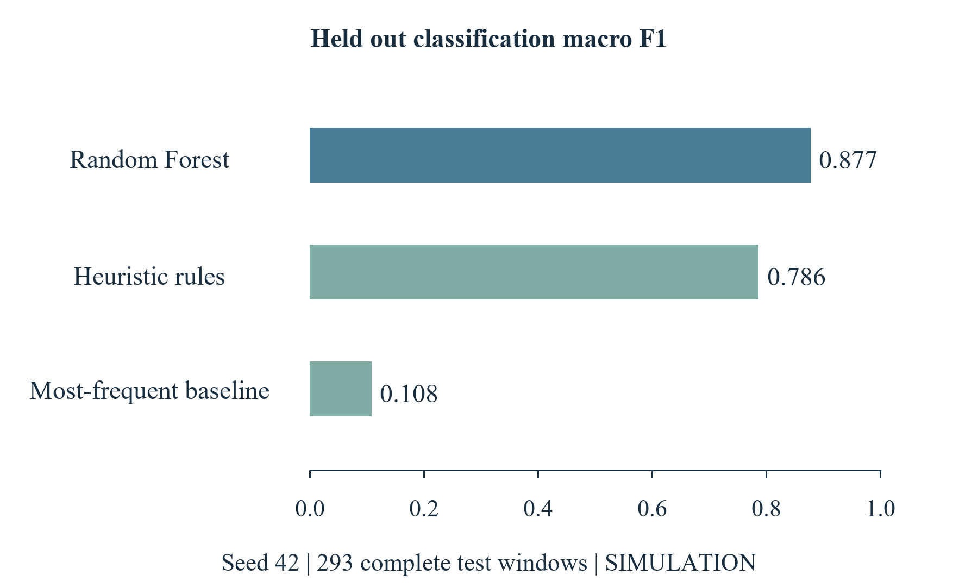
Figure 10 Measured macro F1 comparison on the seed 42 test set
The gap between the dummy model's accuracy and macro F1 illustrates why accuracy alone is insufficient. Routine observations make up 108 of the 293 complete test windows. Predicting routine for every observation therefore gives a non-trivial accuracy while identifying none of the other families. The balanced and macro metrics make that limitation visible.

8 3 Confusion and family level behaviour
The Random Forest correctly classified 100 routine, 47 bulk-transfer, 42 fanout, 34 SYN-burst and 37 UDP-burst observations. The confusion matrix exposes the remaining errors rather than hiding them in a single percentage. For example, four actual bulk-transfer observations were predicted as routine and four as UDP burst. These confusions are consistent with a generator that intentionally includes overlapping feature distributions.
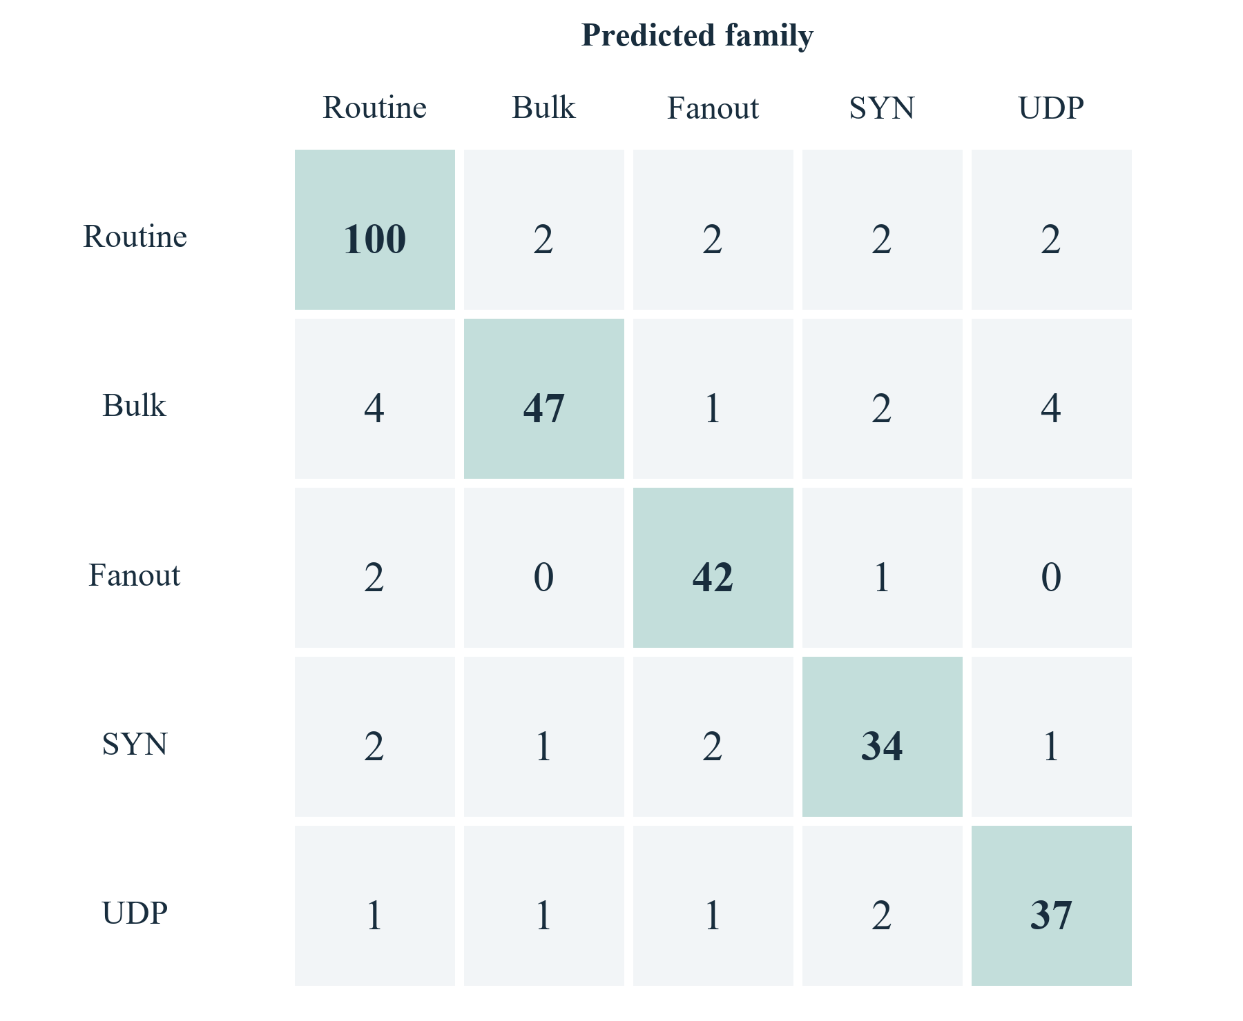
Figure 11 Random Forest confusion matrix with actual families as rows
Table 18 Random Forest per class held out performance
Family | Precision | Recall | F1 | Support
routine | 0.917 | 0.926 | 0.922 | 108
bulk transfer | 0.922 | 0.810 | 0.862 | 58
fanout | 0.875 | 0.933 | 0.903 | 45
syn burst | 0.829 | 0.850 | 0.840 | 40
udp burst | 0.841 | 0.881 | 0.860 | 42

The classifier learned relationships in the generated feature distribution. Its performance cannot establish detection of malware, successful attacks or unfamiliar real traffic. A high family probability means the fitted model favours a particular generated label among its known classes; the model has no independent observation of intent.

8 4 Anomaly detection results
The seed-42 Isolation Forest threshold was 0.650560. Precision was 0.8750, but recall was only 0.0551. The detector flagged seven of 127 challenge observations and one of 166 benign observations, leaving 120 challenges unflagged. The false-positive rate was approximately 0.60 percent, and the false-alert rate was approximately 2.17 per benign virtual hour.
Table 19 Default Isolation Forest operating point
Metric | Measured value | Interpretation
Threshold | 0.650560 | Benign validation 99th percentile
Precision | 87.50% | Seven challenges among eight flags
Challenge recall | 5.51% | Seven of 127 challenge windows flagged
False-positive rate | 0.60% | One of 166 benign windows flagged
Average precision | 0.8724 | Ranking metric across score thresholds
False alerts per hour | 2.1687 | Per complete benign virtual hour
Unscored test windows | 7 | Excluded with explicit availability count

This is an important negative finding. The conservative validation threshold limited false positives but missed most challenge windows. Average precision of 0.8724 describes ranking across score thresholds; it does not repair the low recall at the selected operating threshold. A useful ranking and an unsuitable operating point can coexist.
The result answers RQ2 with a limitation, not a deployment recommendation. Any threshold revision should be specified using validation evidence and then evaluated on a fresh held-out set. Lowering the threshold after observing these test results and reporting the same set as an untouched evaluation would invalidate the protocol.

8 5 Repeated seeds and uncertainty
The repeated-seed study used seeds 42, 43 and 44 at the default configuration. Mean Random Forest macro F1 was 0.8806 with sample standard deviation 0.0104. The heuristic mean was 0.7864 with standard deviation 0.0245, and the dummy mean was 0.1059 with standard deviation 0.0020. These results indicate consistency across three generated seeds, not across real networks.
Table 20 Repeated seed classification and anomaly results
Seed | RF macro F1 | IF recall | False alerts per virtual hour
42 | 0.8774 | 0.0551 | 2.1687
43 | 0.8722 | 0.1852 | 9.1139
44 | 0.8923 | 0.2901 | 2.2500

The per-seed Random Forest whole-run bootstrap intervals were approximately 0.557–0.903, 0.523–0.893 and 0.677–0.915. They are conditional on each fitted model. Only ten test runs are available per seed, and resampling can omit a family; the calculation retains the documented zero F1 convention for absent classes. The wide intervals discourage overinterpretation of small metric differences.
The excluded-family experiment removed complete fanout runs from training and validation, including the background windows in those runs. The classifier could not name a class absent from its training labels. Isolation Forest flagged approximately 0.0, 43.8 and 58.1 percent of the excluded-family observations across the three seeds. These variable rates are not unknown-attack detection accuracy; they are sensitivity to one withheld generated family.

8 6 Explanation and performance results
The default experiment produced eight checked exact-SHAP cases after the tree explanation path failed its guard. The fallback used the actual classifier and retained the required tolerance. RQ3 is therefore supported for the selected cases and implemented fallback, while the failed tree path remains disclosed. Additivity does not establish causal validity or explanation stability across different training backgrounds.
Table 21 Measured single experiment performance
Measurement | Observed value | Scope
Generation | 3.07 s | Metadata and window creation
Training | 0.30 s | Models and calibration
Evaluation | 9.33 s | Metrics, selected explanations and evaluation
Total pipeline | 12.71 s | One measured local run
Peak process RSS | 293.2 MiB | Sampled every 25 ms
Inference p50 | 12.41 ms | Selected single-row inference sample
Inference p95 | 17.06 ms | Same timing sample, not UI latency

The measured pipeline took approximately 12.71 seconds, with a sampled peak process RSS of 293.2 MiB. Generation took 3.07 seconds, training 0.30 seconds and evaluation, including explanations, 9.33 seconds. Median single-row inference time over the selected timing sample was 12.41 ms and the 95th percentile was 17.06 ms. These are measurements from one process and run, not browser response latency or a hardware minimum.
Memory was sampled every 25 ms, so very short peaks may be missed. The process measurement includes imported libraries and does not include all browser, server and operating system memory. The repeated-seed command omits some browser-report work and should not be treated as a directly comparable end-to-end latency benchmark.

8 7 Application results
The completed workbench presents actual job progress, saved experiments, recorded test-window playback, model comparisons, explanations and PDF export. The following screenshot comes from the retained real simulation experiment rather than an illustrative metric fixture. Its SIMULATION badge is part of the product's evidence boundary.
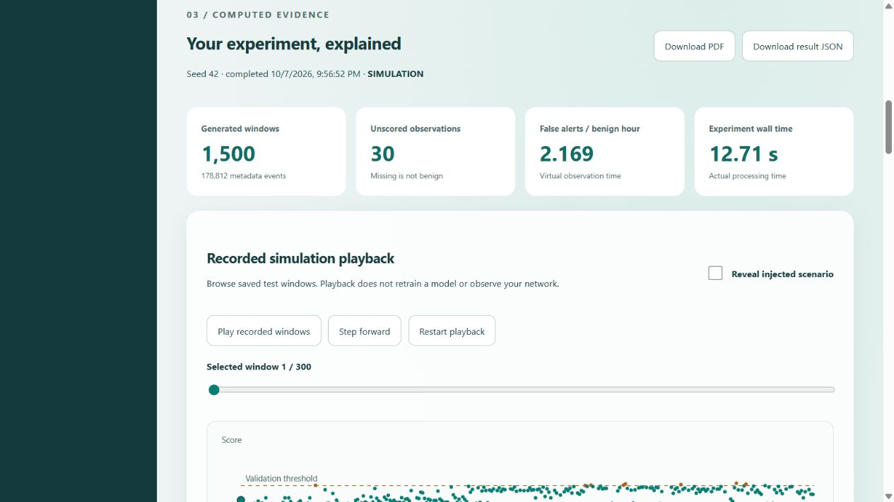
Figure 12 Implemented desktop workbench with actual simulation results
The independent CLI supports the same core experiment without the web application. The launcher and HTTP integration checks demonstrated cancellation and restart persistence in the standalone mode. The public build remained isolated from local routes, and no new public AI deployment was claimed. Together these results support RQ4 for the tested local workflow.

8 8 Threats to validity and discussion
Construct validity is limited by the generated labels. A fanout or burst label identifies a configured behaviour family, not malicious intent. The seven aggregate features may discard details needed to distinguish legitimate and harmful traffic. Missing observations are excluded from metrics, so results apply to the complete observed subset rather than every nominal window.
Internal validity is improved by whole-run partitioning, separate truth records, fixed hyperparameters and train-only references. Nevertheless, train and test data share the same generator assumptions. A model may learn generator-specific regularities that do not transfer to captured traffic. Reproducible synthetic data makes such a limitation inspectable; it does not remove it.
External validity remains unestablished because there is no completed independent dataset or renewed live validation for the new lab models. The three-seed study is small. Conditional bootstrap intervals do not include every source of training uncertainty. Performance observations come from one Windows environment and bounded workload.
The project demonstrates a usable research prototype with evidence that can be inspected and reproduced. Its strongest outcomes are integrated execution, preservation of provenance and transparent model evaluation. Its weakest measured outcome is the anomaly detector's recall at the selected threshold. Reporting that weakness provides a defensible basis for future work rather than an unsupported claim of a production intrusion-prevention system.

Chapter 9 Scope for Future Enhancement

9 1 External validation and measurement compatibility
The first research extension is an independent evaluation dataset obtained through an authorized source. CICIDS2017 access remains blocked pending the official access process [17]. Before using it, an adapter must document how source fields correspond to NetSentinel's observation point, time windows, byte definitions, direction and completeness semantics. An incompatible dataset should be evaluated under a new feature contract rather than forced into host-v1.
Live validation requires a reviewed genuine baseline from the target observation profile and an ethical controlled measurement procedure. A model trained on generated scenarios must remain SIMULATION until compatibility and live validation gates are satisfied. Public-dataset accuracy alone is not sufficient for deployment on a Windows user's network.

9 2 Scientific extensions
Temporal drift experiments could train on an earlier generated or observed period and test on later conditions. Feature ablation could quantify the effect of removing peer count, byte rate or protocol fractions. A broader predeclared seed study could better characterize variance. Threshold calibration should consider a stated operating objective and use fresh test evidence after changes.
An open-set method could explicitly reject unknown behaviours rather than forcing every observation into a known family. This would require a separate definition of unknown data and appropriate evaluation. It should not be inferred from a closed-set Random Forest probability alone. Explanation stability under different background samples and dependent-feature masking also deserves investigation.

9 3 Usability and assistant features
A future local assistant could explain retained facts using a small language model, but it should receive bounded evidence and have no command execution or Windows control authority. Model weights, runtime and hardware performance have not been implemented for this feature. Any generated explanation should remain distinguishable from measured facts and deterministic calculations.
A public recorded showcase could present reviewed synthetic result assets without exposing a training API. It would need clear recorded-simulation labels, a separate export allowlist and verified hosting. User studies could measure whether students correctly interpret missing windows, probabilities and anomalies; the current report contains no invented survey results or usability scores.

9 4 Windows and release engineering
Future native release work includes a hardened installation location, protected service configuration, signed binaries, a documented update policy and measured crash recovery. Controlled live applications should verify packet attribution ambiguity, effective firewall blocking and quota overshoot. Cleanup must continue to remove only rules owned by NetSentinel, never reset the whole firewall.
The project should remain focused. Access schedules, malicious-destination feeds, custom antivirus and speed throttling are deferred extensions. They introduce additional permissions, operational assumptions and maintenance obligations. The immediate priority is stronger scientific validation and completion of existing release gates.
Table 22 Prioritized remaining work
Work item | State | Acceptance requirement
PostgreSQL runtime restoration | BLOCKED | Normal-settings migration and concurrent job acceptance
Official external dataset | BLOCKED | Authorized access, license and measurement adapter
Drift and feature ablation | DEFERRED | Predeclared protocol and fresh held-out evaluation
Local language-model assistant | DEFERRED | Bounded factual context and no control authority
Public recorded AI showcase | DEFERRED | Reviewed synthetic assets and verified public deployment
Windows production release | DEFERRED | Live blocking, overshoot, recovery, hardening and signing

Chapter 10 Conclusion

10 1 Project outcome
NetSentinel implements a complete local workflow for reproducible network behaviour simulation, real model training, held-out evaluation, checked explanations and retained reports. The application connects a modular scientific pipeline to an authenticated browser workbench through a bounded job service. It preserves the independent sensor, public utility and optional Windows companion while keeping their observation and privilege boundaries separate.
The default experiment and repeated-seed study demonstrate useful classification of generated families relative to simple baselines. They also reveal a low-recall anomaly operating point and an explanation compatibility issue that required a verified fallback. These findings are part of the result. The project does not present every unusual observation as an attack or every successful status query as a security guarantee.

10 2 Achievement of objectives
The core objectives were achieved for the standalone simulation prototype: deterministic metadata generation, shared feature extraction, whole-run separation, real estimators, comparison metrics, bounded SHAP, local authentication, cancellation, persistence, playback and semantic reporting. Automated and actual integration checks support the implemented local workflow. The source, contracts, setup guide and evidence locations provide a reproducible handoff.
Remaining boundaries are explicit. PostgreSQL acceptance is blocked in the current environment. External dataset evaluation, a local language-model assistant, a public AI showcase, renewed Windows enforcement acceptance and signing are not completed. These limits do not prevent the current academic demonstration, but they prevent a claim of a production-ready intrusion prevention or antivirus product.

10 3 Concluding remarks
The project shows how an M.Sc. research application can combine scientific discipline with usable software. Reproducibility, visible missing data, protected execution and honest evaluation are as important as a model choice. NetSentinel provides a practical foundation for investigating those concerns and for extending them through independently validated data and controlled future experiments.

Bibliography
References are numbered in order of their assigned bibliography entry. Algorithm papers establish the methods; repository source and retained artifacts establish the implementation and measured results. Online references were reviewed for this report on 8 October 2026 or retained in the project resource inventory. No third-party result is presented as a NetSentinel measurement.
[1] F. T. Liu, K. M. Ting and Z.-H. Zhou, “Isolation Forest,” Proceedings of the Eighth IEEE International Conference on Data Mining, pp. 413–422, 2008. DOI: 10.1109/ICDM.2008.17.
https://cs.nju.edu.cn/zhouzh/zhouzh.files/publication/icdm08b.pdf
[2] L. Breiman, “Random Forests,” Machine Learning, vol. 45, pp. 5–32, 2001. DOI: 10.1023/A:1010933404324. Author manuscript.
https://www.stat.berkeley.edu/~breiman/randomforest2001.pdf
[3] S. M. Lundberg and S.-I. Lee, “A Unified Approach to Interpreting Model Predictions,” Advances in Neural Information Processing Systems 30, 2017. arXiv:1705.07874, version 2.
https://arxiv.org/abs/1705.07874v2
[4] scikit-learn developers, “IsolationForest API reference.” Project implementation uses version 1.9.0; online stable documentation may advance.
https://scikit-learn.org/stable/modules/generated/sklearn.ensemble.IsolationForest.html
[5] SHAP developers, “shap.ExactExplainer API reference.” Project runtime version 0.51.0.
https://shap.readthedocs.io/en/latest/generated/shap.ExactExplainer.html
[6] Django Software Foundation, “Django 5.2 documentation,” models, migrations and security guidance.
https://docs.djangoproject.com/en/5.2/
[7] Vercel, “Next.js documentation,” application routing and deployment.
https://nextjs.org/docs
[8] Scapy contributors, “Scapy documentation,” packet capture and packet processing interfaces.
https://scapy.readthedocs.io/en/latest/
[9] psutil contributors, “psutil documentation,” process, memory and network connection APIs.
https://psutil.readthedocs.io/en/latest/
[10] Microsoft, “Get-MpComputerStatus,” Defender PowerShell reference.
https://learn.microsoft.com/en-us/powershell/module/defender/get-mpcomputerstatus
[11] Microsoft, “New-NetFirewallRule,” NetSecurity PowerShell reference.
https://learn.microsoft.com/en-us/powershell/module/netsecurity/new-netfirewallrule
[12] Cloudflare, “speedtest,” official browser speed-test component repository and measurement documentation.
https://github.com/cloudflare/speedtest
[13] ipwhois.io, “IP Lookup API and IP Geolocation Documentation.” Service terms and limits must be reviewed separately before deployment.
https://ipwhois.io/documentation
[14] jsPDF contributors, “jsPDF,” client-side PDF generation project.
https://github.com/parallax/jsPDF
[15] ReportLab, “ReportLab PDF Toolkit User Guide.”
https://docs.reportlab.com/reportlab/userguide/ch1_intro/
[16] J. Arkko, M. Cotton and L. Vegoda, “IPv4 Address Blocks Reserved for Documentation,” RFC 5737, January 2010.
https://www.rfc-editor.org/rfc/rfc5737
[17] Canadian Institute for Cybersecurity, University of New Brunswick, “Intrusion detection evaluation dataset CIC-IDS2017.” Referenced as future evaluation data; not used in the reported experiments.
https://www.unb.ca/cic/datasets/ids-2017.html
[18] SQLite authors, “SQLite Foreign Key Support.”
https://www.sqlite.org/foreignkeys.html
[19] Django REST Framework contributors, “Django REST framework documentation.”
https://www.django-rest-framework.org/
[20] NetSentinel project repository, branch codex/ai-lab-prototype, source checkpoint d0fbbb1. Primary implementation evidence: plan.md, docs/AI_LAB_CONTRACT.md, source models and retained experiment JSON. Reviewed 8 October 2026.
https://github.com/hariharan4814/NetSentinel-upgraded

Appendix A Installation and User Manual

A 1 Laboratory installation
Use Windows x64, Python 3.11 and Node.js 22 or later. Open a terminal in the repository root. The following commands describe a new source checkout; do not recreate a prepared environment unnecessarily. The laboratory lock targets Windows CPython 3.11 wheels. A different platform requires its own reviewed dependency resolution.
py -3.11 -m venv .venv-lab
.\.venv-lab\Scripts\python.exe -m pip install --require-hashes -r requirements-lab.lock
py -3.11 -m venv .venv-backend
.\.venv-backend\Scripts\python.exe -m pip install -r requirements-backend.txt
cd frontend
npm ci
npm run build
cd ..
.\.venv-lab\Scripts\python.exe scripts/run_ai_lab.py
The launcher prompts for a local password of 32 to 256 printable characters without spaces. Use the same value for the browser sign-in. It is not printed or saved by the launcher. The launcher generates distinct service credentials in memory and opens http://127.0.0.1:3105/lab. The backend binds to 127.0.0.1:8811. Do not launch either web server as administrator.
If the verified wheel cache is available, an offline lab installation can add --no-index and --find-links resources/ai-lab/downloads/wheels to the hash-required pip command. The resource manifest contains official origins and hashes; downloaded papers, models and datasets should not be indiscriminately copied into a public release.

A 2 Running an experiment
After sign-in, retain the default settings for a first demonstration. Start the experiment and watch the reported stage rather than expecting an invented percentage. When it succeeds, inspect the dataset counts, compare model metrics, open an explanation and use playback to inspect recorded test windows. Enable the truth overlay only when discussing the generator labels.
Repeat the same seed and configuration to compare dataset hashes. Then change one setting, such as noise, and observe the calculated result. Use cancellation on a larger bounded job to demonstrate operational control. Download the PDF or JSON from a completed result and check that its scope is SIMULATION.

A 3 Shutdown and recovery
Ctrl+C in the launcher stops its owned processes and preserves results. On the next startup, sign in with the new launcher password. If an earlier job was interrupted, the queue marks an expired running lease as failed when accessed; create a new job after resolving the cause. The application must not rewrite an interrupted job into a completed result.
The standalone state is under artifacts/lab/standalone. Back up or remove this directory only while its processes are stopped and only when the operator intends to remove the demonstration history. Original PostgreSQL data and companion state are separate. Occupied ports can be changed with the launcher's frontend-port and backend-port options; unrelated services must not be terminated.

A 4 Independent command line use
.\.venv-lab\Scripts\python.exe -m lab demo --out artifacts/lab/my-demo --seed 42
.\.venv-lab\Scripts\python.exe -m lab inspect artifacts/lab/my-demo
.\.venv-lab\Scripts\python.exe -m lab benchmark --out artifacts/lab/my-study --seeds 42 43 44
The command-line pipeline does not need Django, Next.js, PostgreSQL or Npcap. Use a fresh output directory. Generated model files remain trusted local artifacts and must not be downloaded from unknown sources and deserialized. Benchmark output is a separate research-study contract rather than a browser job result.

A 5 Supporting applications
The public helper requires only a browser. HTTP checks, speed testing and provider lookup are separate user actions with different data costs and external services. History is optional. The companion requires its documented Windows prerequisites and explicit capture setup; its dashboard and privileged broker are separate processes. Read docs/COMPANION_SETUP.md and docs/COMPANION_UPGRADE.md before enabling native controls.
The original /local monitor requires the original research settings and PostgreSQL. Do not serve the application with Django test settings to bypass missing production configuration. A missing Defender service, passive antivirus state, insufficient permission or unavailable capture driver must be presented as unavailable or limited rather than as a healthy security state.

Appendix B API and Data Contracts

B 1 Configuration contract
Table 23 Accepted scenario configuration fields
Field | Default | Allowed values
seed | 42 | Integer 0 to 2147483647
runs_​per_​family | 10 | Integer 6 to 30
windows_​per_​run | 30 | Integer 12 to 120
intensity | 1.0 | Finite number 0.5 to 2.0
noise | 0.15 | Finite number 0 to 1
gap_​probability | 0.02 | Finite number 0 to 0.15

The mode is fixed to SIMULATION and is not a browser-supplied configuration value. Unknown keys are rejected. Integer fields reject booleans and fractional values. Float fields reject NaN and infinity. Global limits cap an experiment at 20000 windows and 2000000 metadata events, with at most 512 events in one window; reaching a limit is an explicit failure rather than silent truncation.

B 2 Job requests and responses
A create request contains one config object with every required setting. Read responses return a job identifier, state, stage, UTC timestamps, configuration, cancellation state, optional progress counts and a bounded error. A successful detail response also contains its result. Lease digests, raw credentials and worker artifact paths are omitted from browser serialization.
POST /api/v1/lab/jobs/
Content-Type: application/json
Authorization: Bearer <lab credential supplied securely>
{ "config": { "seed": 42, "runs_per_family": 10, "windows_per_run": 30, "intensity": 1.0, "noise": 0.15, "gap_probability": 0.02 } }
The worker claim response contains a job or null. A lease is returned only to the authenticated worker. Heartbeats send the active lease and actual progress. Finish accepts only SUCCEEDED, FAILED or CANCELLED, and success requires a fully validated result. A finish operation cannot be assumed replayable after a network failure; inspect retained state before deciding whether a retry is appropriate.

B 3 Result schema
Table 24 Principal lab result v1 sections
Section | Contents
schema_​version and mode | lab-result-v1 and SIMULATION
generated_​at and config | UTC generation timestamp and normalized settings
dataset | Digest, event/​window counts, feature order and split identities
models and references | Actual parameters and training-derived quantiles
classification | Models, metrics, per-class values and confusion matrices
anomaly | Threshold, precision, recall, false positives and unavailable counts
timeline | Bounded held-out observations, predictions and generated truth
explanations | Method, model output, baseline, feature contributions and error
performance | Wall-clock stages, sampled RSS and inference sample timings
limitations | Explicit interpretation and measurement restrictions
displayed_​windows and total_​test_​windows | Presentation count distinct from evaluation count

Numbers unavailable because evidence is missing use null, not NaN or a fabricated zero. The result exposes total and displayed window counts separately. The frontend may sample timeline points for drawing while aggregate metrics continue to use every complete test observation. Consumers must not recalculate whole-experiment accuracy from only the displayed subset.

B 4 Boundary failures
Malformed input produces a validation failure. Missing or incorrect credentials produce authentication failure, and insufficient scope denies the requested action. Queue pressure is reported explicitly, including HTTP 429 for admission when four jobs are waiting. Unknown identifiers, stale leases and invalid transitions cannot silently mutate another job. Exact error contracts are implemented in the backend and gateway test suites.

Appendix C Database Data Dictionary

C 1 Dictionary conventions
The following tables are derived from current model declarations and the companion SQL schema. Django logical field types are shown so the dictionary remains valid for the explicit laboratory SQLite mode and the original PostgreSQL mode; the physical storage representation depends on the database backend. PK means primary key, FK means declared foreign key, and nullable means that the database can store a missing value.
Inherited SessionRecord fields are repeated for clarity in each concrete research entity. It is an abstract Django class and is not an additional table. Application-level validation complements the listed column types. The tables contain metadata and aggregates; no field is intended to store packet payloads, passwords or browsing content.

C MonitoringSession fields
Table 25 monitoring MonitoringSession data dictionary
Field | Logical type | Null | Meaning
session_​id | UUID | No | Primary key. Related monitoring session.
source_​id | UUID | No | Source identity.
run_​id | UUID | No | Groups sessions from one capture run.
interface_​name | Text (255) | No | Selected local observation interface.
mode | Text (10) | No | LIVE, SIMULATION or REPLAY.
started_​at | Datetime | No | Session start time.
observation_​profile | Text (80) | No | Measurement scope and capability profile.
schema_​version | Text (40) | No | Versioned record contract.
received_​at | Datetime | No | Server receipt time.
payload_​digest | Text (64) | No | Integrity and idempotency digest.

C CaptureStatus fields
Table 26 monitoring CaptureStatus data dictionary
Field | Logical type | Null | Meaning
id | UUID | No | Primary key. Generated or supplied row identity.
session_​id | FK MonitoringSession | No | Declared foreign key; CASCADE on delete. Related monitoring session.
received_​at | Datetime | No | Server receipt time.
payload_​digest | Text (64) | No | Integrity and idempotency digest.
observed_​at | Datetime | No | Observation time.
state | Text (20) | No | Capture lifecycle state.
valid | Boolean | No | Whether the observation is usable.
reason | Text (255) | Yes | Reason for unavailable observation.
loss_​started_​at | Datetime | Yes | Beginning of a monitoring gap.
gap_​ended_​at | Datetime | Yes | End of the monitoring gap.
monitoring_​gap_​seconds | Float | No | Duration of unavailable monitoring.
recovery_​attempts | Unsigned integer | No | Recovery attempt count.

C TelemetrySample fields
Table 27 telemetry TelemetrySample data dictionary
Field | Logical type | Null | Meaning
id | UUID | No | Primary key. Generated or supplied row identity.
session_​id | FK MonitoringSession | No | Declared foreign key; CASCADE on delete. Related monitoring session.
received_​at | Datetime | No | Server receipt time.
payload_​digest | Text (64) | No | Integrity and idempotency digest.
observed_​at | Datetime | No | Observation time.
elapsed_​seconds | Float | No | Actual interval used for rates.
measurement_​source | Text (20) | No | Source of the measurement.
valid | Boolean | No | Whether the observation is usable.
reason | Text (255) | Yes | Reason for unavailable observation.
bytes_​sent | Unsigned bigint | No | Cumulative operating-system counter.
bytes_​received | Unsigned bigint | No | Cumulative operating-system counter.
packets_​sent | Unsigned bigint | No | Cumulative operating-system counter.
packets_​received | Unsigned bigint | No | Cumulative operating-system counter.
delta_​bytes_​sent | Unsigned bigint | Yes | Nullable counter difference for the interval.
delta_​bytes_​received | Unsigned bigint | Yes | Nullable counter difference for the interval.
delta_​packets_​sent | Unsigned bigint | Yes | Nullable counter difference for the interval.
delta_​packets_​received | Unsigned bigint | Yes | Nullable counter difference for the interval.
upload_​bytes_​per_​second | Float | Yes | Nullable rate in bytes per second.
download_​bytes_​per_​second | Float | Yes | Nullable rate in bytes per second.

C TrafficWindow fields
Table 28 telemetry TrafficWindow data dictionary
Field | Logical type | Null | Meaning
id | UUID | No | Primary key. Generated or supplied row identity.
session_​id | FK MonitoringSession | No | Declared foreign key; CASCADE on delete. Related monitoring session.
received_​at | Datetime | No | Server receipt time.
payload_​digest | Text (64) | No | Integrity and idempotency digest.
features | JSON | Yes | Nullable seven-feature sidecar.
feature_​schema_​version | Text (40) | Yes | Versioned feature order and semantics.
capture_​context | JSON | Yes | Observation capability context.
start | Datetime | No | Window start time.
end | Datetime | No | Window end time.
finalized_​at | Datetime | No | Aggregation finalization time.
processed_​at | Datetime | No | Processing time.
measurement_​source | Text (20) | No | Source of the measurement.
schema_​version | Text (40) | No | Versioned record contract.
partial | Boolean | No | Whether the window is incomplete.
valid | Boolean | No | Whether the observation is usable.
reason | Text (255) | Yes | Reason for unavailable observation.
packets | Unsigned bigint | No | Packets.
ip_​bytes | Unsigned bigint | No | Ip bytes.
outbound_​packets | Unsigned bigint | No | Outbound packets.
inbound_​packets | Unsigned bigint | No | Inbound packets.
unknown_​packets | Unsigned bigint | No | Unknown packets.
outbound_​bytes | Unsigned bigint | No | Outbound bytes.
inbound_​bytes | Unsigned bigint | No | Inbound bytes.
unknown_​bytes | Unsigned bigint | No | Unknown bytes.
tcp_​packets | Unsigned bigint | No | Tcp packets.
udp_​packets | Unsigned bigint | No | Udp packets.
other_​packets | Unsigned bigint | No | Other packets.
flow_​count | Unsigned integer | No | Number of observed flow keys.
dropped | Unsigned integer | No | Dropped metadata count.
kernel_​loss | Text (10) | No | Capture-loss availability state.

C ModelVersion fields
Table 29 detection ModelVersion data dictionary
Field | Logical type | Null | Meaning
id | UUID | No | Primary key. Generated or supplied row identity.
manifest | JSON | No | Versioned model metadata, not model binary.
received_​at | Datetime | No | Server receipt time.
payload_​digest | Text (64) | No | Integrity and idempotency digest.

C AnomalyResult fields
Table 30 detection AnomalyResult data dictionary
Field | Logical type | Null | Meaning
id | UUID | No | Primary key. Generated or supplied row identity.
session_​id | FK MonitoringSession | No | Declared foreign key; CASCADE on delete. Related monitoring session.
received_​at | Datetime | No | Server receipt time.
payload_​digest | Text (64) | No | Integrity and idempotency digest.
window_​id | FK  telemetry.  TrafficWindow | No | Declared foreign key; CASCADE on delete. Window id.
model_​version_​id | FK ModelVersion | No | Declared foreign key; PROTECT on delete. Model version id.
observed_​at | Datetime | No | Observation time.
scored_​at | Datetime | No | Analysis execution time.
anomaly_​score | Float | No | Deviation score; not attack probability.
label | Text (10) | No | NORMAL or ANOMALOUS.

C QueueGuard fields
Table 31 experiments QueueGuard data dictionary
Field | Logical type | Null | Meaning
id | Unsigned smallint | No | Primary key. Generated or supplied row identity.
revision | Unsigned smallint | No | SQLite queue guard lock update.

C Companion apps fields
Table 32 Companion apps physical schema
Field | SQLite type | Key or null | Meaning
id | TEXT | PK; see note | Executable path hash.
path | TEXT | Required | Canonical executable path; private.
name | TEXT | Required | Executable display name.
protected | INTEGER | Required | Critical application protection flag.
seen | REAL | Required | Last observation in UTC epoch seconds.

C Companion usage fields
Table 33 Companion usage physical schema
Field | SQLite type | Key or null | Meaning
app | TEXT | PK | Logical app identity or unassigned.
day | TEXT | PK 2 | UTC date bucket.
mode | TEXT | PK 3 | Observation provenance.
up | INTEGER | Required | Observed outbound IP bytes.
down | INTEGER | Required | Observed inbound IP bytes.

C Companion policies fields
Table 34 Companion policies physical schema
Field | SQLite type | Key or null | Meaning
app | TEXT | PK and FK; see note | Primary and foreign key to apps.id.
daily | INTEGER | Nullable | Daily byte quota, nullable.
monthly | INTEGER | Nullable | Monthly byte quota, nullable.
warning | INTEGER | Required | Warning percentage, default 80.
direction | TEXT | Required | Quota direction, default combined.
auto | INTEGER | Required | Explicit automatic blocking flag.
override | REAL | Required | Temporary unblock expiry in UTC seconds.
manual | INTEGER | Required | Persisted manual block intent.

C Companion events fields
Table 35 Companion events physical schema
Field | SQLite type | Key or null | Meaning
id | INTEGER | PK | Row identity.
at | REAL | Required | UTC epoch timestamp.
app | TEXT | Nullable | Optional logical app identity.
category | TEXT | Required | Quota, control or security category.
code | TEXT | Required | Structured event code.
message | TEXT | Required | Bounded explanation.
mode | TEXT | Required | Observation provenance.
marker | TEXT | Nullable | Unique optional deduplication marker.

C Companion flows fields
Table 36 Companion flows physical schema
Field | SQLite type | Key or null | Meaning
id | INTEGER | PK | Row identity.
app | TEXT | Nullable | Optional logical app identity.
at | REAL | Required | Observation timestamp.
protocol | TEXT | Required | Observed TCP or UDP.
remote | TEXT | Required | Remote IP metadata; private.
port | INTEGER | Nullable | Remote port when available.
up | INTEGER | Required | Attributed upload IP bytes.
down | INTEGER | Required | Attributed download IP bytes.
mode | TEXT | Required | Observation provenance.

C Companion destinations fields
Table 37 Companion destinations physical schema
Field | SQLite type | Key or null | Meaning
app | TEXT | PK; see note | Logical app identity; key component.
remote | TEXT | PK 2; see note | Observed remote address; key component.
mode | TEXT | PK 3; see note | Provenance; key component.
at | REAL | Nullable | Last observation timestamp.

C Companion settings fields
Table 38 Companion settings physical schema
Field | SQLite type | Key or null | Meaning
key | TEXT | PK; see note | Preference identifier.
value | TEXT | Required | JSON encoded local preference.

SQLite schema note: a declared primary key in an ordinary rowid table does not always imply NOT NULL for non-integer columns. The current companion statements omit explicit NOT NULL on several text key fields; application validation supplies their intended values. A future schema migration should address this deliberately. Composite key numbers above indicate the declared key order, not separate keys.

C 2 Integrity and normalization
The research schema separates sessions, telemetry, windows, model metadata and analysis results to avoid repeating session identity and provenance in every value. Child rows use session foreign keys and observation-time uniqueness. Traffic windows enforce directional and protocol conservation, time ordering and consistency between partial, valid and reason fields. Model deletion is protected when anomaly results reference the model.
The lab schema trades deep relational metric querying for a bounded complete-result JSON document, with strict application validation. The companion normalizes executable identity and policy while aggregating usage by application, UTC day and provenance. Its SQL declares fewer foreign keys than its logical relationships; future strengthening must preserve the unassigned usage case and migration compatibility.

C 3 Migration and storage procedures
The lab application has three additive migrations: initial jobs, QueueGuard creation and singleton seeding. The original research migrations are preserved. The source launcher applies only the explicit standalone lab configuration. Companion SQLite uses user_version 1 and rejects unknown versions. A schema version should be changed only with a documented migration and backup path.
Retention limits rows and observation age, but deleting SQLite rows does not necessarily reduce the database file immediately. Storage maintenance must be planned separately from logical retention. Backup and cleanup procedures must avoid including secrets or private inventories in public project submissions.

Appendix D Test Execution and Acceptance Procedures

D 1 Repeatable commands
.\.venv-lab\Scripts\python.exe -m unittest discover -s tests/lab -p "test_*.py"
.\.venv-backend\Scripts\python.exe backend/manage.py test tests --settings=config.test_settings
.\.venv-backend\Scripts\python.exe backend/manage.py makemigrations --check --dry-run --settings=config.test_settings
.\.venv-lab\Scripts\python.exe scripts/verify_ai_lab.py
cd frontend
npm test
npm run lint
npm run typecheck
npm run build
npm run test:e2e
npm run build:public
Run commands with their intended environments and required configuration. Django test_settings is for isolated tests only. A test database is not a running product configuration. Build and browser checks should use a prepared production frontend when validating release behaviour.

D 2 Manual academic demonstration
1. State the problem and the SIMULATION boundary before showing metrics.
2. Start the local launcher and sign in without displaying any password or token.
3. Run the default scenario and show actual generation, training and evaluation stages.
4. Explain the whole-run split and show the number of unavailable test windows.
5. Compare Random Forest, heuristic rules and the dummy baseline using macro F1 and the confusion matrix.
6. Show the low anomaly recall and explain the threshold trade-off without changing test results.
7. Open a SHAP case and relate the contribution sum to the model output.
8. Use recorded playback and the truth overlay, explaining that neither is live traffic.
9. Download a report, cancel another job and reopen retained history after restart.
10. Conclude with the measured limits and the next external validation gate.

D 3 Remaining Windows verification
Use explicitly authorized, controlled applications and record the selected interface, executable identity and observation coverage. Compare independent controlled transfer bytes with attributed IP bytes while documenting layer and retransmission differences. Exercise multiple processes with the same executable, ambiguous sockets and traffic that remains unassigned.
Enable enforcement only for a suitable controlled application. Record separately whether the owned rule was applied and whether new traffic was actually blocked. Measure bytes beyond a quota threshold and the delay between observation, reconciliation and effective blocking. Verify temporary overrides, UTC resets, restart persistence and protection of critical executables.
Test normal shutdown cleanup and abnormal process termination followed by recovery. Inspect only NetSentinel-owned rules and retain evidence that unrelated rules remain unchanged. Defender scan testing must be explicit, handle unavailable or passive states and avoid claiming percentage progress that Windows does not expose. No malicious sample is required for the academic simulation demonstration.

Appendix E Evidence Register and Release Handoff

E 1 Source and generated evidence
The source repository is https://github.com/hariharan4814/NetSentinel-upgraded. The report's inspected branch is codex/ai-lab-prototype and the source checkpoint is d0fbbb1. The draft review is pull request 1 and is not merged. The report preparation changes documentation and generated document artifacts only.
The genuine default experiment is retained below artifacts/lab/browser-qa-20261006/experiments/856e32e1-6c30-4b6e-97d2-fc35e877cdac. Its result.json supplies the principal tables in Chapter 8. The directory name reflects the start of browser QA; the final cited experiment completed on 7 October 2026.
Table 39 Retained evidence locations relative to the repository
Artifact | Location and purpose
Final integration result | artifacts/​lab/​integration-20261007-220124/​verification.json
Repeated seed study | artifacts/​lab/​repeated-seed-study-v2/​benchmark.json
Default result | browser-qa-20261006 experiment directory identified above
Desktop and mobile evidence | artifacts/​lab/​desktop-verified.png and mobile-verified.png
Application-generated PDF | output/​pdf/​NetSentinel-AI-Lab-SIMULATION.pdf
Reviewed source archive | artifacts/​release/​NetSentinel-AI-Lab-source.zip
Resource sources and hashes | resources/​ai-lab/​manifest.json
Durable execution history | plan.md and YT.md
Executable and API contract | docs/​AI_​LAB_​CONTRACT.md

The dataset SHA-256 is de4c289d3f3916769ecdf0f32db44c494c40c9b589d7fd9876319da292c50fe6. This digest identifies the generated dataset; it is not a digital signature or proof of authorship. Generated models, datasets and screenshots are intentionally excluded from normal source control and must be preserved separately for reproduction when moving machines.

E 2 Release classification
The local AI prototype is implemented and verified within the evidence scope recorded here. PostgreSQL acceptance and official external dataset acquisition remain blocked. The language-model assistant, public AI showcase, drift and ablation work, production Windows acceptance and signing are deferred. A source archive is available, but it is not a signed installer.
The existing public connection site is https://netsentinel-connect.hariharan4814.chatgpt.site. Its recorded successful publication predates the completed AI laboratory. This report does not claim that /lab is publicly deployed or that the public site can control an installed Windows companion. Only the allowlisted public artifact is eligible for website publication.

E 3 License and attribution record
scikit-learn 1.9.0 is used under BSD-3-Clause and SHAP 0.51.0 under MIT, with retained license texts. The locked transitive numerical packages have their own license and notice obligations. The project uses Django, React, Next.js and PDF libraries as dependencies; those upstream algorithms and frameworks are credited rather than represented as original work.
The source release does not republish the downloaded research papers or optional dataset. Service terms for public measurement endpoints are separate from software licenses and must be rechecked before broader promotion. No project-wide license grant is inferred for the owner's source merely because its dependencies are open source.

Appendix F Glossary and Viva Notes

F 1 Glossary
Table 40 Project abbreviations and terms
Term | Meaning in this project
API | Application Programming Interface
ASN | Autonomous System Number
CSRF | Cross-Site Request Forgery
DFD | Data Flow Diagram
ER | Entity Relationship
IF | Isolation Forest deviation model
RF | Random Forest classifier
SHAP | SHapley Additive exPlanations
RSS | Resident Set Size of a process
UTC | Coordinated Universal Time
LIVE | Genuine observations from the stated observation point
SIMULATION | Generated metadata, explicitly separated from live evidence
REPLAY | Previously recorded compatible observations processed later
Provenance | Origin, mode, version and context needed to interpret data
Unscored | No valid model result for an unavailable or incomplete observation
Macro F1 | Unweighted mean of the specified per-class F1 scores
Lease | Expiring worker authority to complete one claimed job

F 2 Questions for the project demonstration
Why use simulation? It permits repeatable experiments and privacy-preserving demonstrations without sending attack traffic. Why use two models? The classifier identifies generated families, while the anomaly detector measures deviation from benign training behaviour. Their tasks and metrics are different.
Why split whole runs? Windows from one run share generation context. A random window split can make test observations too similar to training observations. Why keep a dummy baseline? It shows how much apparent accuracy comes from class frequency. Why is macro F1 useful? It gives each specified class equal weight rather than allowing routine traffic to dominate the summary.
Does SHAP prove the cause of a prediction? It explains the fitted model relative to a specified background and masking procedure, not a real-world cause. Does a low anomaly score prove safety? No; it means the observation did not exceed this model's threshold. Why report poor recall? Because the measured limitation is necessary for a scientifically valid conclusion and guides the next experiment.
Can the public website capture packets or block an application? No. Capture belongs to the separately installed native software, and privileged controls require the narrowly scoped broker. Can the simulation model be used for LIVE traffic immediately? No. Matching feature names do not establish measurement compatibility or live performance.

F 3 Submission completion fields
Replace the cover placeholders with the approved student, institution, supervisor and academic-year details. Add institution-specific certificate, declaration and signature pages only using the approved wording and genuine signatures. The technical chapters, tables and experiment findings should retain their stated scope and dates when the cover is completed.

